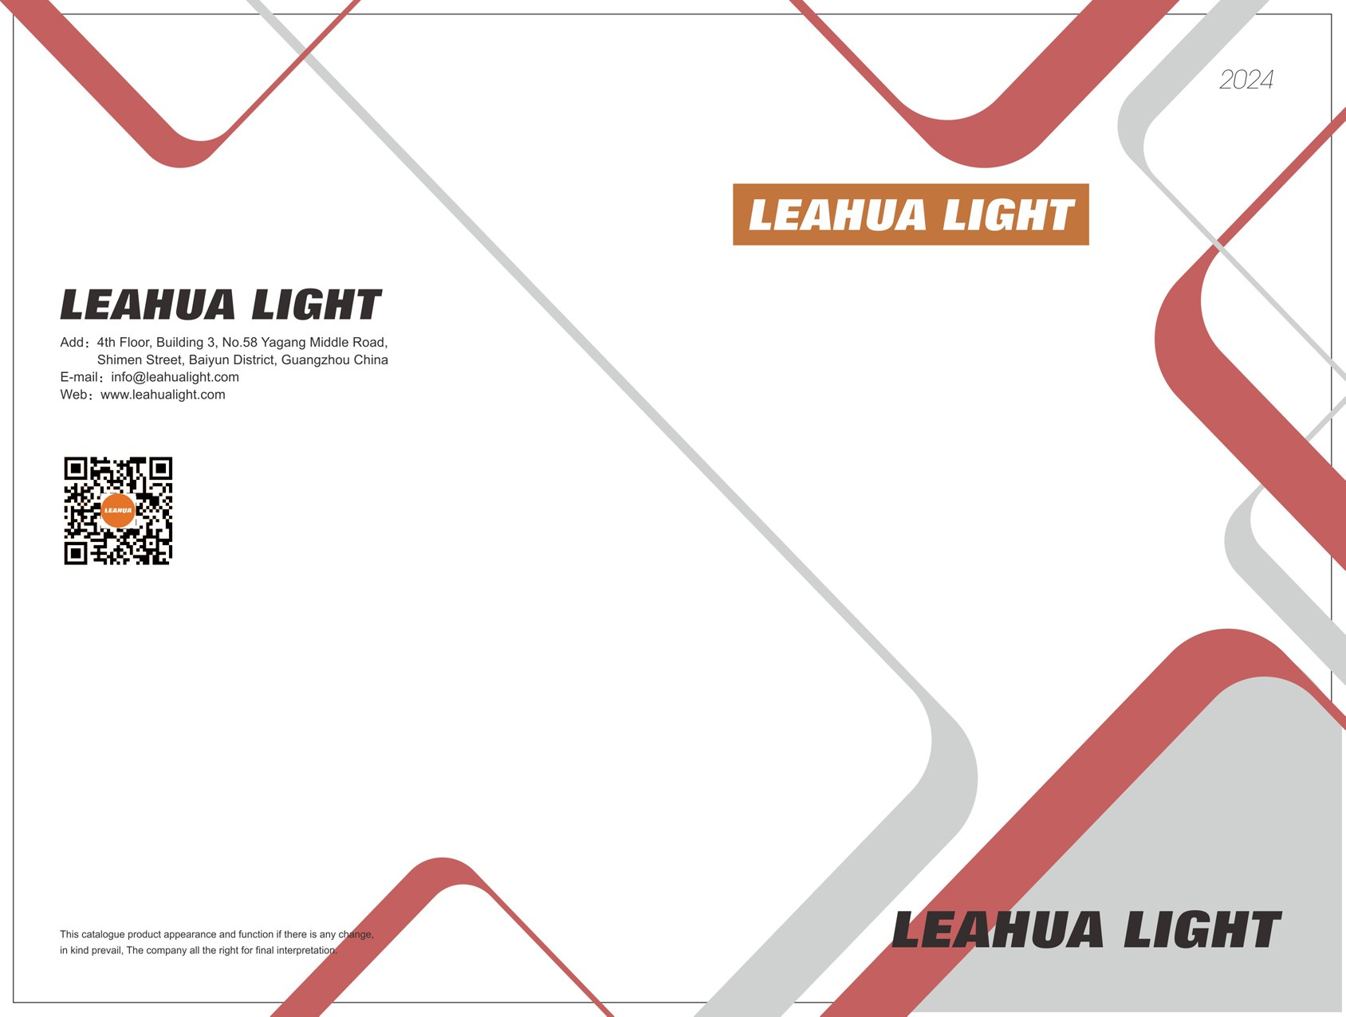

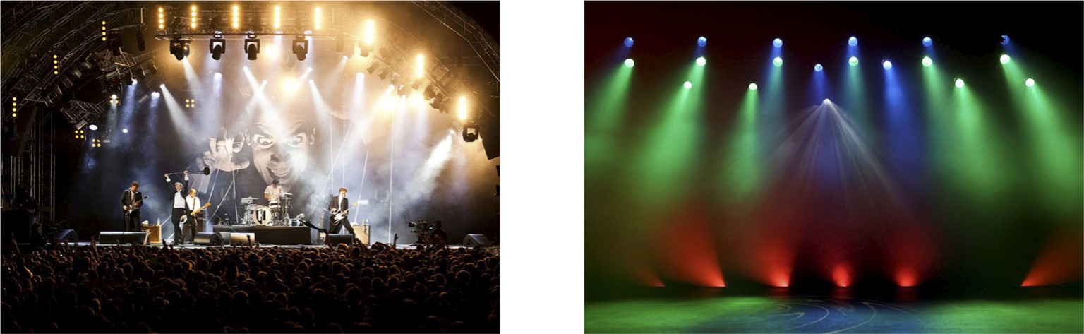

Certification About us

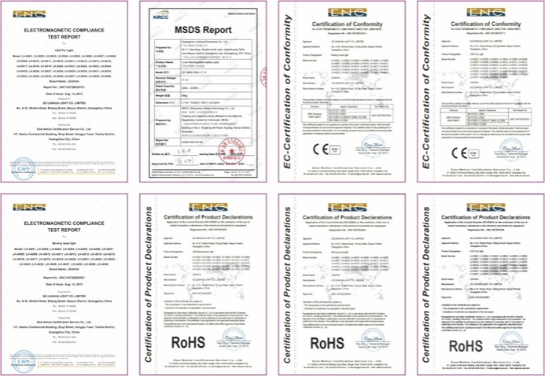GZ Leahua Light co., Limited, established in 2012 and located in Baiyun District, Guangzhou, is a high-tech enterprise specializing in the design, manufacture and sales Of stage lighting.

At present, Leahua has the world's leading stage equipment: beam light, led moving head light, led par light, battery light, stage effect light, outdoor light, etc. it has a strong and technical team to support OEM and ODM manufacturing.

Leahua has 3000 square meters of factory, more than 50 employees and multiple production lines, with a monthly production capacity of 3000 sets of lights.

After nearly 10 years Of development, the company has built a leading products and capacity, manufacturing capacity and marketing capacity in the stage entertainment lighting industry. The products are exported to domestic and foreign markets, the corporate image continues to improve and the social influence continues to grow.

Since its establishment, adhering to the core concept Of "self-improvement and value creation", and the quality policy of "customer satisfaction is our goal", the company has rapidly improved its business scale and quality. Accordingly, the company has put forward the vision and goal of "becoming the most dynamic leader in the stage entertainment lighting industry". It has established the goal of becoming stronger and better and building "the most professional comprehensive service provider in the stage music and lighting industry".

Looking forward to the future, Leahua will certainly provide more high-quality products and services for the majority Of users in the new development stage, and make greater contributions to the society, the country and China's manufacturing industry.

Case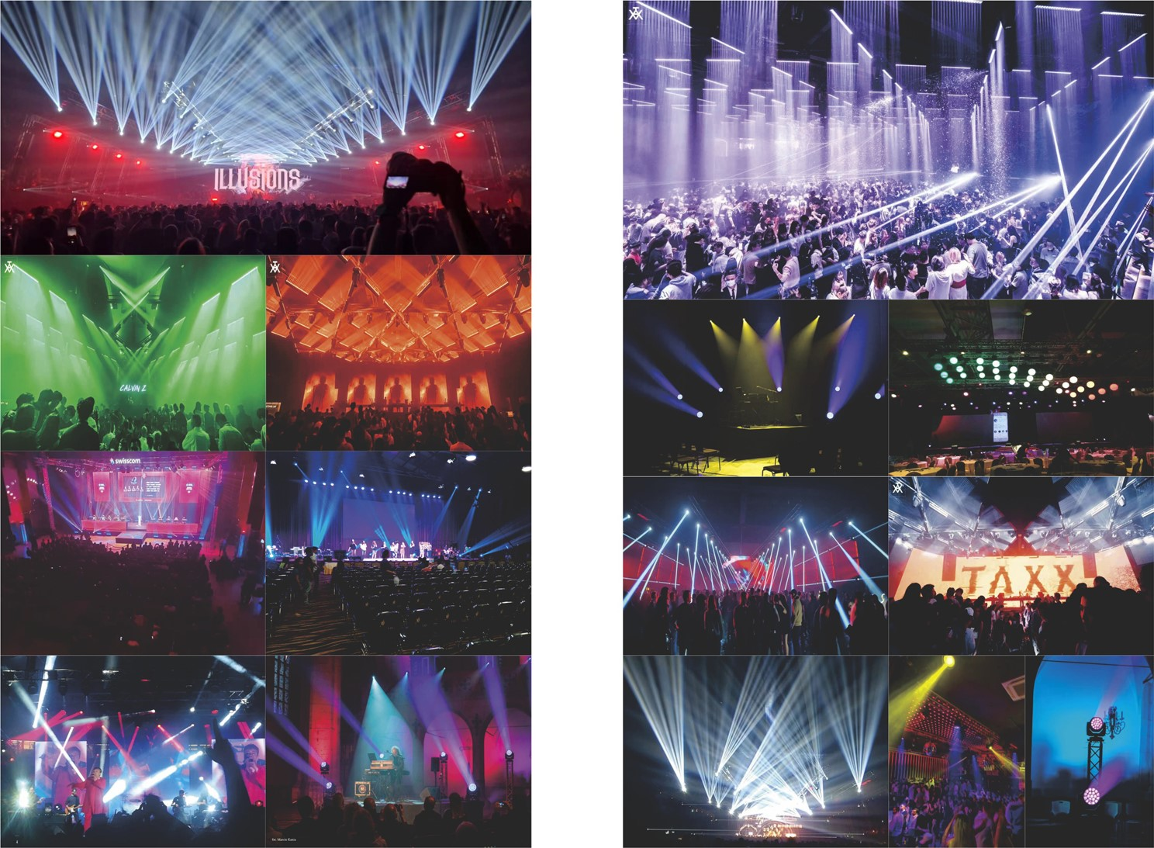Case

01

# BSW

## Moving Head Light

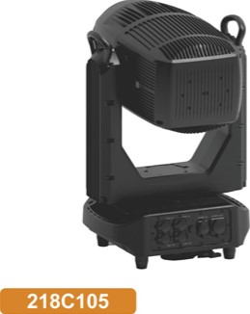218C105 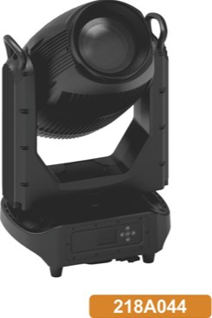218A044

500W BSW 470W BSW

Beam

## Moving Head Light

### 218C101 218A043

#### LED 410W Lamp 470W

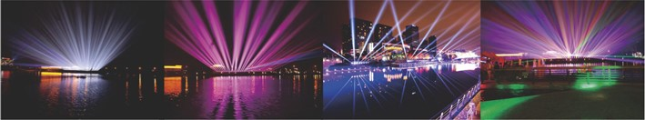

|  |  |  |  |  |  |  |
| --- | --- | --- | --- | --- | --- | --- |
| Model NO.  Input | 218C105  ACIOOV-240V | 218A044  SO,GOHZ |  | Model NO. | 218C101 | 218A043 |
| power  Light source | 500W Led module | 461W Lamp | Input | ACIOOV-240V  550W | 50/60HZ  550W |
| Led life | 20000Hrs | | Light source Led life | 4 IOW Led module 461W Lamp  20000Hrs | |
| Zoom angle  Color temperature | 2_aOdegree | | Beam angle temperature | 2—40degree | |
| Working temperature  Control mode | 0-40tc  ROM | | Color  Working temperature | 0-40C | |
| Channel | DMX512. Master-slave.Auto.  26CH | | Control mode  Channel | DMX512, Master-slave,Auto, ROM  16CH | |
| Colors wheel  Static gobos wheel | 13 fixed colors*bIank.WIth half coky and linear adjustment furttion. can achieve tilateral raintx:w effect  12 gobos*blank. with shake and bilateral rotation | | Colors wheel | 14 fixed colors+blank.Wlth Mlf color and linear adjustment function, can achieve bilateral rainbow effect | |
| Rotating gobos wheel | 7 gobos•blank.with shake and bilateral rotation | | Colorful wheel | 6coIors | |
| prism | Double prism wheel, 2prism Independently rotating. can be superimposed by prisms | | Static gobos wheel | 17 gobos+blank. with shake and bilateral rotation | |
| Frost | I frost wheel | |  | Double prism wheel, 2prism independently rotating. can be superimposed by prisms | |
| CW  CTO | Independent CMY wheel Independent CIO wheel | | Frost | I frost wheel | |
| Dimmer  Strobe | linear dimmer  Independent strobe channel. I —20times/s. speed ad" ble | | Dimmer  Strobe | 0—100% linear dimmer  Independent strobe channel, I —20times/s, speed adjustable | |
| rate  movement | IP65. waterproof | | IP rate  Pan movement | IP65, waterproof S40degree 16bit | |
| Pan  Tilt movement | 340degree 16bit  270degree 16bit | | Tilt movement Display | 270degree 16bit  LCD display with 5touch buttons | |
| Display  Signal connect | LCD display with Slouch buttons DMX 39in in/Out*5pin in/out | | Signal connect | DMX 3pin in/out+5pin in}out | |
| Power connect | Power con in/out | | Power connect Product size | Power con in/out  396•31œ708rnm | |
| Product size Net weight |  | | Net weight | 35kg | |

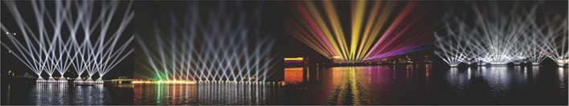

03 04

## 1000w 19x40w LED spot Framing Moving Led Moving Head

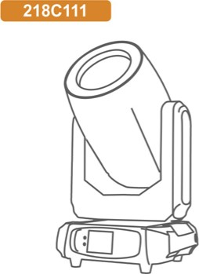 In Coming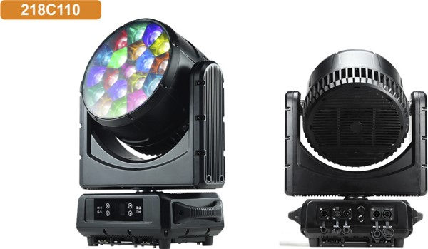

|  |  |  |  |  |  |  |  |  |  |  |  |  |  |  |  |  |  |  |  |  |  |  |  |  |  |  |  |  |  |  |  |  |  |  |  |  |  |  |  |  |  |  |  |  |  |  |  |  |  |  |  |  |  |  |  |  |  |  |  |  |  |  |  |  |  |  |  |  |  |  |  |  |  |  |  |  |  |  |  |  |  |  |  |  |  |  |  |  |  |  |  |  |  |
| --- | --- | --- | --- | --- | --- | --- | --- | --- | --- | --- | --- | --- | --- | --- | --- | --- | --- | --- | --- | --- | --- | --- | --- | --- | --- | --- | --- | --- | --- | --- | --- | --- | --- | --- | --- | --- | --- | --- | --- | --- | --- | --- | --- | --- | --- | --- | --- | --- | --- | --- | --- | --- | --- | --- | --- | --- | --- | --- | --- | --- | --- | --- | --- | --- | --- | --- | --- | --- | --- | --- | --- | --- | --- | --- | --- | --- | --- | --- | --- | --- | --- | --- | --- | --- | --- | --- | --- | --- | --- | --- | --- | --- | --- |
| |  |  | | --- | --- | | Model NO. | 218C111 | | Input Voltage | ACIOO-240V 50-60Hz | | Light Source | 1000'" white LED. 8000K | | LED lifetime | 20000 hours | | CRI |  | | Movement | Pan 540' &Tilt 270' . With super quiet movement and automatic error reset | | Framing | 4 groups and eight directions of blade. multiple design | | Static gobo wheel | 12 gobos open | | Rotating gobo wheel | 7 gobos open. interchangable. indexable | | Animation wheel | I animation wheel with outstanding water and flame effect | | Color Wheel | One color wheel with 6 colors* Open | |  | Independent CTO.color temperature can be linear adjusted | | CMY | Independent CMY. with linear color change.excellent color macro effect | | prism | 3 prism. with rotate in either direction | | Focus | Automatic focus | |  | 50 — 550 Linear zoom | | Iris | 5%— 100% motorized linear iris a4ustment | | Dimming | O— 100% linear dimming | | Strobe | 0—20Hz .W1th strobe effect. 1—25 times/second | |  | 35' —65' With frost effect. with 3 frost lever—heavy. medium and light | | Display | LCD display | | Control Mode | DMX 512. ROM, Auto—running . Master—ve. Sound active. Built—in Program | | DMX Channel |  | | Clamp | The unique folded hanging clamp system makes this product more practical and convenient | |  | 36kg | |  | 38.5kg | | |  |  | | --- | --- | | Model NO. | 218C110 | | Input Voltage | AC90-260V 50/60Hz | | Power Consumption | 880th' | | Light Source | 19pcs 40W 4-IN-I LEDs (R, G, a, | | LED Feature | Individual LED control Of each color | | Life time | SOOOOhours | | Zoom range | 5_4Sdegree | | Control mode  Channel | DMX512.Master/slave. Sound.Auto  21 | | Effect | Beam. Wash. FX(KaIeidoscope effects) | | Lens | Bi—directional rotating front lens | | Dimmer | O— 100% smoothly dimmer | |  | 1 —25Hz. speed adjustable | | Color temperature | 7800K | | Displa | LCD display,easy navigation to change Chinese/EngIish.can make screen inverted 180 degrees | | Movement | Pan 540degree, 16bit; Tilt 205degree, 16bit | | DMX in/out | 3 pin,' 5pin XLR DMX in,'out | | power connection | Powercon in/out | | Protection rating | IP65. waterproof | | Product size | 408x302.1x490.1mm | | Net weight | 22_63KG | |
|  |

05 06

## 28x45w 120w Led Moving Head Led beam Moving

### 029C109

|  |  |  |  |  |
| --- | --- | --- | --- | --- |
| Model NO. | 218C110C |  | Model NO. | 029C109 |
| Voltage | ACI 10-220V 50-60Hz | Input voltage | ACI 10-240'v' SO,'60Hz |
| Power | 1260W | power consumption | 200w |
| Light Source | 28 LEDs 45'" RGBW 4in1. each led pixel control | Light source | 120W LED White |
| Led life | 50.000 hours life expectancy | Working lifetime  Working temperature | About 50000 hours |
| Color Temperature(range) | 2700 to 8000K  4_60 | Beam angle | -20tc-aoec  1.60 |
| Zoom Range  Dimmer Strobe | to 53.60 ,twO zones independently 12)  O— 100% linear dimmer  0—20Hz. | Control mode | DMX 512. Auto. Master-slave.Sound. BDM |
| Channel mode | 14 CH |
| Control mode | speed adjustable  DMX512. Master,'slave. Auto. ROM | Color wheel  Gobo wheel | 13 With variable direction and speed,with rainbow effect.  17 static gobos•white, rotation With variable direction and speed |
| DMX Channels | loch. 22ch. 27ch. 28ch. 84ch. 112ch. 134ch, 224ch,252ch. 308 or 323ch | prism | Iprism wheel: 8+16 prism, bi—directional rotatable at variable speeds |
| rate | IP65. temporary outdoortwet use | Colorful wheel | I colorful wheel |
| Working temperature | -20' Ct045' C | Dimmer | O— 100% mechanical dimming |
| Movement  Exterior Color | Pan540a .16bit_ | IP rate | 0-25Hz  65 |
| Power Connection | Seetronic Powerkon IP65 irlout |  | pan: 540' Electric correction. 16bit; Tilt: 270' Electric correction. 16bit |
| Data Connectors | 3—pin IP rated XLR in/out | power connector  DMX connector | Powercon in/out  3-pin XLR DMX in/out+ 5—pin XLR DMX in/out |
| Product size | 408x302_ Ix4901 mm  2263kg | Net weight | 1 1.38kg |
| Feature | Beam. Wash. Led Pixel control.zoom two zones independently control | Packing size  Gross weight | 13.25kg |



08

|  |  |
| --- | --- |
| Led Strobe | 10*60w RGBW |
| Moving Head | LED Moving Head Bar |

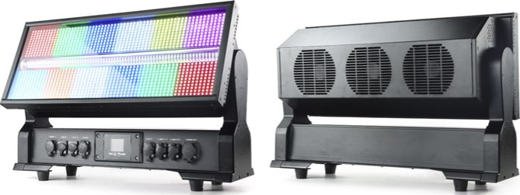218H028B 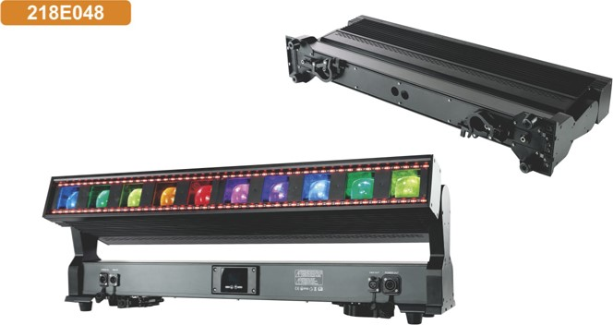

|  |  |  |  |  |  |  |  |  |  |  |  |  |  |  |  |  |  |  |  |  |  |  |  |  |  |  |  |  |  |  |  |  |  |  |  |  |  |  |  |  |  |  |  |  |  |  |  |  |  |  |  |  |  |  |  |  |  |  |  |  |  |  |  |  |  |  |  |  |  |  |  |  |  |  |  |  |  |
| --- | --- | --- | --- | --- | --- | --- | --- | --- | --- | --- | --- | --- | --- | --- | --- | --- | --- | --- | --- | --- | --- | --- | --- | --- | --- | --- | --- | --- | --- | --- | --- | --- | --- | --- | --- | --- | --- | --- | --- | --- | --- | --- | --- | --- | --- | --- | --- | --- | --- | --- | --- | --- | --- | --- | --- | --- | --- | --- | --- | --- | --- | --- | --- | --- | --- | --- | --- | --- | --- | --- | --- | --- | --- | --- | --- | --- | --- |
| |  |  | | --- | --- | | Model NO. | 218H028B | | Input Voltage | ACIOO-240V 50,60Hz | | power  Light Source | locow | | Led Feature | 1320pcs o.5w RGB 5w White color  Around RGB 12section control individual: Centre VThite 12sections control individual | | Beam Angle | 22' | | LED Life Time | 50000 hours | | Max. Ambient Temp. | 45C/113' F | | DMX Channels  Control mode | DMX 512, master—slave , Auto | | Dimmer | 0_ 100% electronic | | Strobe | 0-20Hz | | Display | Colorful LCD display | | Cooling | Efficient low noise fan cooling system | | Tilt movement | 185' .16bit | | power connector | Powercon IN,' OUT | | Signal connection | a—pin XLR connectors IN,'OUT. 5—pin XLR connectors IN/OUT.Artnet RJ45 IN/OUT | | IP rate | IP65. waterproof | | Product Dimension | 587mm •242mm•352mm | |  | 24.6KG | | |  |  | | --- | --- | | Model NO. | 218E048 | | Input voltage range | ACIOO-240V 50/60 Hz | | power consumption |  | | LED source | Main Light: lox 60W RGBW LED multichip | | Backlight | 96x1VV CW LED: WW LED: 96xo.5W RGB LED | | Led feature | Main Light Each Led control individual | |  | Backlight White 24 sections control; RGB 24 sections control | | Zoom range | 5-170 | | Dimmer | linear dimmer | |  | 0-25Hz | | Channel  Control Mode | 1 68/170CH  DMX512, Master/slave, Auto,RDM | | Display | LCD display with 4buttons | | LED life expectancy | Min. 50.000 hours | | Tilt movement | 202' 116 bit movement resolution | | power connector | Seetronic Powercon in/out | | DMX iniout | 3—pin XLR in out | | Software update | Upgrade software via DMX connection | | rate | IP65 | | Feature | Beam Wash. Color mixing , Zoom | | Product Dimensions | 1 1 ooxl 22x350mm | |



09 10

|  |  |
| --- | --- |
| LED 10*60w Moving Head | Led Moving Head |

|  |  |  |
| --- | --- | --- |
| Model NO. | 218E044E | 218E042C |
| Input Voltage | ACI 00-240V 50/60Hz | |
| Light source | IOpcs LED each 40 W, RGBW 4in1 | 20x 40W RGBW LED multichip |
|  | 400W |  |
| Led Feature | Individual control Of each RGBW LED pixel | |
| Led life | 50.000 hours life expectancy | |
| Zoom Angle | 5.8—60' , motorized zoom | 30 — 600 . motorized zoom |
| DMX Channels | 33CH/19CH/34CHQ8CH/29CH/48CH/49CH | 20CH/34CH05CH/48CH/49CH,B8CH/89CH |
| Control mode | DMX 512, master—slave , Auto | |
| Dimmer | linear dimmer | |
| Strobe | Max 20Hz electronically | |
| Cooli | Efficient IOW noise fan cooling system | |
| variable CTO | 2.700K - 8.000K | |
| Feature | LED point control.beam and wash effect. seamless combine, splicing without gaps. | |
| IP rate | IP65, waterproof | |
|  | 240degree. 16bit movement resolution | 205degree. 16bit movement resolution |
|  | Colorful LCD display | |
| Power connector | Powercon IN/ OUT | |
| Data connector | 3-pin XLR DMX IN,'OUT | |
| Product Dimension | S36x159.1x398.4mm | 1035M5g•381mm |
|  | 18KG | 29_5kg |

|  |  |
| --- | --- |
| Model NO | 218E0441 |
| Input Voltage | ACIOO-240V 50,'60Hz |
|  |  |
| Light Source | 10pcs LED each 60 W. RGBW 4in1 |
| Led Feature | Each led controlled individual |
| Led life | 50.000 hours life expectancy |
| Zoom Angle  DMX | 5.8—600 . motorized zoom |
| Channels  Control mode | DMX 512. master—slave . Auto |
| Dimmer | O— 100% linear dimmer |
|  | Max 20Hz electronically |
| Cooling | Efficient IOW noise fan cooling System |
| variable CTO | 2700K - 8000K |
| Feature | LED point control.beam and wash effect. seamless combine.sp'icing without gaps. |
| rate | IP65. waterproof |
| Tilt movement | 240degree. 16bit |
| Display | Colorful LCD display |
| power connector | Powercon IN/ OUT |
| Data connector | a-pin XLR DMX IN,'OUT |
| Product Dimension | 536xI 59.1098.4mm |
|  | 18KG |

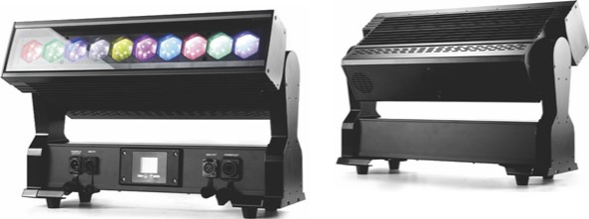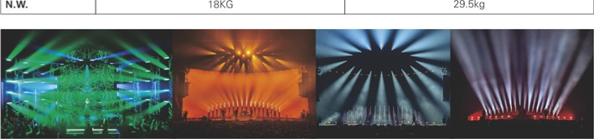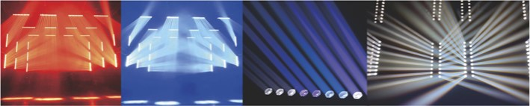 218E0441

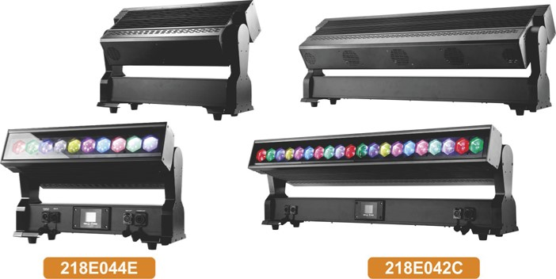

10*40W

20*40W

1 1 12

|  |  |
| --- | --- |
| 10*40W ZOOM | 18*40W ZOOM |
| LED Bar Light | LED Bar Light |

### LH-E021 LH-E044 LH-E029 LH-E043

RGBW RGBW IP RGBW RGBW IP

|  |  |  |  |  |  |  |
| --- | --- | --- | --- | --- | --- | --- |
| Model NO. | LH-E021 | LH-E044 |  | Model NO. | LH-E029 | LH-E043 |
| Input Voltage | ACI 00-240'.' 50-60Hz | | Input Voltage | ACIOO-240V 50-60Hz | |
| power |  | | Power | 720vv | |
| Light Source | 10pcs LED each 40W RGBW 4in1 | | Light Source | 18x 40W RGBW 4inl LED multichips | |
| Led Feature | Each led controlled individual | | Led Feature | Individual control Of each RGBW pixel | |
| Led life | 50.000 hours life expectancy | | Led life | Min. 50.000 hours | |
| Zoom Angle  DMX | 3-60' | | Zoom Angle | 40 — 600 , 2 independent zoom zones | |
| Channels  Control mode | DMX 512, master—slave , sound , Auto | | DMX Channels | 16CH/27CH/76CH/88CH  . . | |
| Dimmer | O— 100% electronic | | Control mode Dimmer | DMX 512. master-slave sound Auto  0—100% electronic | |
| Shutter | Max 1 OHz electronically | | Shutter | Max 20Hz electronically | |
| Display | Colorful LCD display  Efficient low noise | | Display | LCD display | |
| Cooling  Tilt movement | 220degree | fan cooling system  24Odegree | Cooling | Efficient low noise fan cooling system | |
| Power connector | PowerCON IN/ OUT | | Tilt movement | 205' , 16 bit movement resolution | 2400 , 16 bit movement resolution |
| DMX connector | 3—pin XLR connectors IN/OUT | | Power connector | PowerCON IN/ OUT | |
| IP rate | Ip20 |  | DMX connector  IP rate | 3pin DMX in/out | |
| Dimension  N.W. | 9.5kg | 607 x 122.3 x 350.9 mm  15.67KG | Product size | 993x137.8x291. I mm | 1077X122.3x319.9mm |
| Carton | 59œ23œ430mm  12.08k | 17.29kg | N.W.  Feature | 18.3kg 24 kg  Beam Wash effect, with zoom function, Tilt Movement | |



13 14

|  |  |
| --- | --- |
| 20*40W ZOOM | 10*60W Led Bar Zoom |
| LED Bar Light | Moving Head Light  LH-E047 |

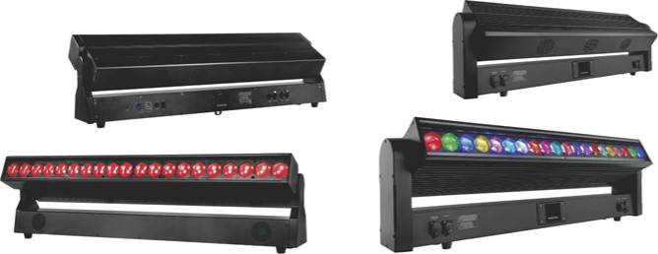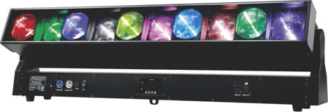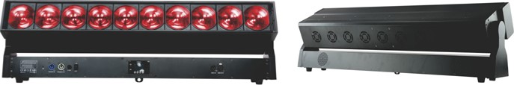 LH-E030 LH-E042

RGBW RGBW IP

|  |  |  |  |  |  |
| --- | --- | --- | --- | --- | --- |
| Model NO. | LH-E030 | LH-E042 |  | Model NO. | LH-E047 |
| Input Voltage | ACIOO-240V 50-60Hz | | Input voltage range | AC 100-240 V 5060 Hz |
| Power |  | | Power consumption | 600w |
| Light Source | 20x40w RGBW LED multichip | | LED Source | 1()• RGBW LED 4in1 |
| Led Feature | Each led pixel control | | LED feature | Each led individual control |
| Led life | Min. 50.000 hours | | Zoom | 3.70 - 35 |
| Zoom Angle | 3' -600 | | Zoom feature | Each led Individual zoom control in out |
| DMX Channels | 20CH/34CH/35CH/48CH/49CH/88CH/89CH | | LED life | 50.000 hours |
| Control mode | DMX 512, master—slave , sound , Auto | | Control | DMX512, master/slave, Auto, Sound, RDM |
| Dimmer | liner dimmer | | Channel | 25/51/57/79CH |
| Strobe | Max 20Hz | | Dimmer | linear dimmer |
| Display  Variable CTO | LCD display | | Strobe | Electronic strobe effect with variable speed up to 20 Hz |
| Tilt movement | 2.700K - 8.000K  2050 ; 16 bit movement resolution | | Dispaly | LCD dispaly with 4 buttons |
| Power connector | PowerCON IN/ OUT | | IP rate | IP20 |
| DMX connector | 3pin DMX in/out | | Tilt | 1850 , 16bit |
| IP rate |  |  | Power connector | Powercon in/out |
| Dimension | 1011.4x137.8x333.1mm | 1101x122_3x350.9mm | DMX connector | XLR 3pin in/out |
| N.W. | 19.8 | 25_5KG | Product Dimensions | 1013x137x329mm |
| Featu re | LED point control.two zoom zone control. beam and wash effect | | Net weight | 24kg |



15 16

|  |  |
| --- | --- |
| Model NO. | 218E0221P |
| Power Supply | AC 100-240W50-60Hz |
| power consumption | oow |
| Light source | 24pcs•4W LED RGBW 4in1 mixing color |
| LED feature | Create dazzling effects with 2 18 zones of individual control |
| Beam Angle | 25degreeloptional) |
| Dimmer | dimmer |
| Strobe rate | 0-24HZ |
| Working Environment | -20tc-40ec |
| rate | IP65 |
| DMX Channels Control Mode | 6/8,'14/50ch  slave. wireless |
| Control panel | DMX512,Master-  LED display |
| Power connect | Powercon in out |
| DMX control | apin XLR DMX in out |
| Product size | 6.85kg |
| Battery type | Lithium Ion |
| Battery lifespan | 500times circulation |
| Battery Charge Time | 6hours(full power) |
| Battery Life | (All on) 4.5hours.(single Color) 16 hours |
| Battery Power | 12V. 16000mAh |

|  |  |  |  |
| --- | --- | --- | --- |
| Model NO. | LH-F096A | LH-F096B | LH-F096C |
| Power Supply | DC18V-25QV | | |
| power consumption Light source | 12Bpcs•O.25VV  LED | 64W  RGBW LED | 64W |
| LED Feature | Iæætms.eæh LEDs |  | 12;xs LEDs |
| CRI | CRI>90 | | |
| Dimmer | Linear dimmer | | |
| Strobe | 0-24Hz | | |
| Control mode  Channel | Wireless DMX. IR Remote. Master—slave. Auto. Sound. | | |
| Working Environment | 806/132CH 10/52,'124CH  -20tc-40ec | | |
| rate |  | | |
| Display | Touch Keypress | | |
| power connector | Charging Port | | |
| DMX in/out | 3.5mmTRS to a—pin XLR | | |
| Net Weight | 2.4kg |  | 4.4kg |
| Product size | 055mm. L1000mm | 055X2037mm | 076X1552rnm |
| Charging | By DC charging cable or in flightcase | | |
| Battery type | Lithium Ion | | |
| Battery power | N. 8000mAh | 12.6V. 16AH | 12V.12000mAH |
| Battery Charge Time | 6hours(full power) | ull power) | 5hours(full power) |
| Battery Life | hours(all on) optional. more than 20hourslsingIe color) | | |
| Wireless effective distance | 200meters | 400meters | 400meters |
| Device On | Long Press Menu 3s | | |
| Device Off | Press UP*Down meantime— —Shutdown— —Enter | | |

## Battery LED IP65

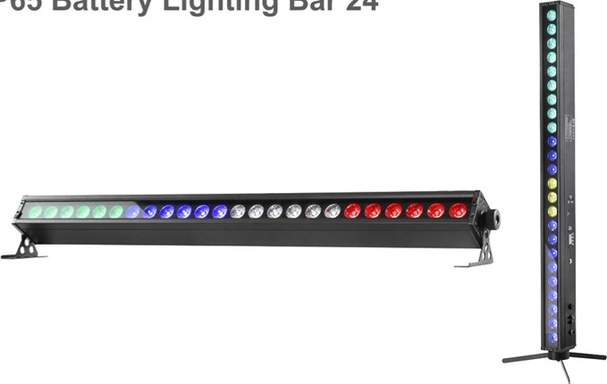

Battery

Lighting

Bar

24

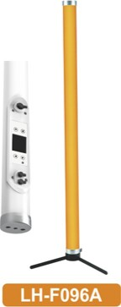

RGBW

# Tube Light IP

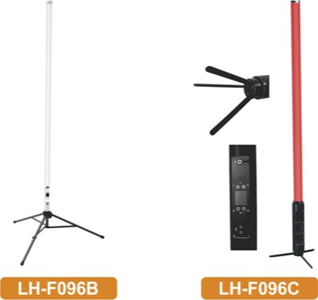LH-F096C

2M 360 RGBWA

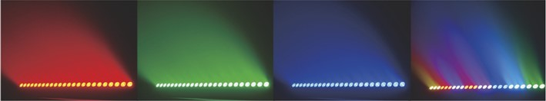

17 18

IP65 19*15W Zoom IP65 7*20w 6in1

LED Par Light led Par

218D098D

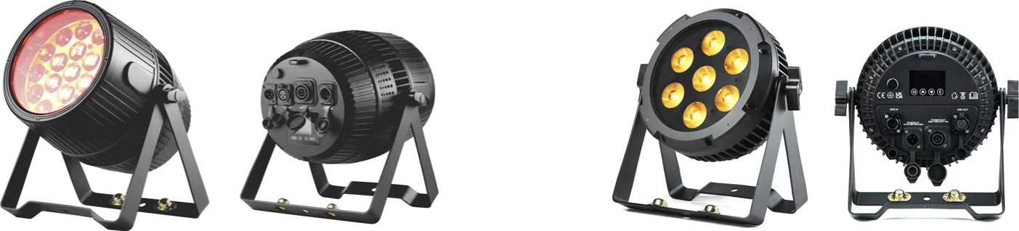

|  |  |  |  |  |  |  |  |  |  |  |  |  |  |  |  |  |  |  |  |  |  |  |  |  |  |  |  |  |  |  |  |  |  |  |  |  |  |  |  |  |  |  |  |  |  |  |  |  |  |  |  |  |  |  |  |  |  |  |  |  |  |  |  |  |  |  |  |
| --- | --- | --- | --- | --- | --- | --- | --- | --- | --- | --- | --- | --- | --- | --- | --- | --- | --- | --- | --- | --- | --- | --- | --- | --- | --- | --- | --- | --- | --- | --- | --- | --- | --- | --- | --- | --- | --- | --- | --- | --- | --- | --- | --- | --- | --- | --- | --- | --- | --- | --- | --- | --- | --- | --- | --- | --- | --- | --- | --- | --- | --- | --- | --- | --- | --- | --- | --- |
| |  |  | | --- | --- | | Model NO. | LH-D068L | | Input Voltage | AC90-260V 50,'60Hz | | Light Source | 19pcs 15W 4-IN-I LEDs (R. G. B. | | Power Consumption |  | | Zoom range | 15_60degre,e | | Control mode | DMX512.master—slave,Sound„AutO | | Channel | 22/1 ICH | | Life time |  | | Feature | With both wash and beam effect. 3 LED zones with individual control of each | | Dimmer | O—100% smoothly dimmer | | Strobe | 20t/s strobe effect with variable speed | | Cooling | Low noise and efficient Fan cooling system 2pcs fans | | IP rate | Ip.65 | | Signal data | 3—Pin XLR DMX input/output | |  | Powercon In lout | | Net weight | 9.22kg | | Packing size |  | | |  |  | | --- | --- | | Model NO. | 218D098D | | Input voltage range | ACIOO-240V 50/60 Hz | | power consumption | 1 IOW | | LED Source | 7x 20W RGBA4Cyan4Lirne 6in1 LEDs | | Dimmer | 0—100% linear dimmer | | Strobe | O- 20Hz | | Control mode | DMX512, master/slave, Auto, RDM | | DMX channels | 1 CH/6CH/9CH/19CH | | Adjust Refresh Rate | 2KHz/10KHz/15KHz/20KHz | | Effect | Adjust Strobe and Dimming Curve Modes: Built—in Auto&colour mode effect | | IP Rate |  | | Display | Easy—to—use 4—button control panel with OLED display | | IP Power in/out connector | True one in/out | | IP 5-pin XLR | DMX input/output | | Net Weight | 4.52KG | | Product Dimensions | 309x144.8x255mm | |



19 20

Strobe Light Battery LED

LED Moving Head Light Moving Head Light



## 218C002

20W Gobo 4x8W

|  |  |  |
| --- | --- | --- |
| Model NO. | 218C002 | 218C002A |
| voItage | 1 10-220V, 50-60Hz | |
| power |  |  |
| Light source | 20%' led white | 4•aw RGBW 4in1 LED |
| Led life | 50000 hours life expectancy | |
| Working temperature | -200 c -450 c | |
| Dimmer | 0—100% linear dimmer | |
| Strobe | 0—24times/s, speed adjustable | |
| Control mode | DMX512. Master/slave. Auto. Sound, Wireless.Remote | |
| DMX Channels |  | 16/14ch |
| IP rate | IP20 | |
| Wireless Distance | 400 meters rainbow effect | |
| Color Wheel Gobos | 7gobos + white. with rainbow effect |  |
| Movement | Pan 5400 ,16bit: Tilt 2700 , 1 6bit_ | |
| Exterior Color | alack | |
| Displa | LED display | |
| Power Connection | IEC power in | |
| Drnx Connectors | 3—pin XLR in/out | |
| Product size | 206x186.3x260mm | 206x186.3x205mm |
|  | 39kg | 3.2kg |
| Batte cha time | Lithium Ion  7hOurs | |
| Batte life | More than 5hours | |

|  |  |
| --- | --- |
| Model NO. | LH-H028 |
| Input Voltage | ACI 00-240V 50,'60Hz |
| Power |  |
| Light Source | 1320pcs o.2w RGB 3in1 +216pcs lw cold White color |
| Section control | RGB 12sections(6x2)  Cold white 12sections |
| Resolution | 8-16 bit |
| Tilt movement | 1850 |
| Maximum ambient temperature | 450 C 1130 F |
| DMX Channels  Control mode | DMX 512, master—slave sound , Auto |
| Dimmer | 0-100% Electronic |
| Display | Colorful LCD display |
| Cooling | Efficient low noise fan cooling system |
| Power connector | Seetronic PowerCON IN/ OUT |
| Data socket | 3—pin and 5pin XLR IN/OIJT. Artnet RJ45 IN/OUT |
| Dimension Net weight | 14.12KG |
| IP rating | IP20, indoor |
| Carton  G.w. | 15.73KG |

12V 8800mAh



21 22

BSW LED 300W LED Zoom 4*60W

## Moving Head Light Moving Head Light

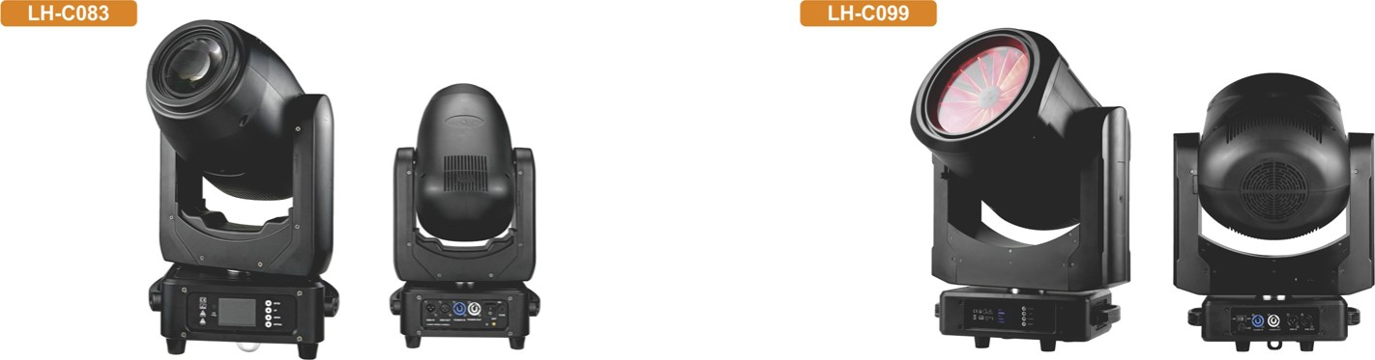

|  |  |  |  |  |
| --- | --- | --- | --- | --- |
| Model NO. Input voltage | LH.C083  ACI 10-240',' 50,60Hz |  | Model NO. | LH.C099 |
| Power  Light source |  | Power supply | ACI 00-240V 50/60Hz  250W |
| Working lifetime | 1 pcs 300W LED White color  About 50000 hours | Lamp Source | 4 x 60W RGBW LEDs |
| Working temperature Channel | -20zc-aocc  16,Q2CH | LED Average Life | 50.OOOH |
| Control mode power Socket | DMX 512. Auto. Master-slave | Led feature | 30 —350 Electronic Zoom Range  Individual LED control for each parameter |
| DMX socket | PCM.'ercon InJOut 3p,n DMX INOut | MY Wheel  Gobo wheel | Magenta, Yellow |
| Movement  Housing color |  | Operati ng mode | I gobo  DMX512, master/slave. auto.sound |
| Housing material Display | ABS*Alloy  LCD display | rate | IP20 |
| Net weight | 13.25KG | Feature | Zoom, beam, Frost Effects |
|  |  | Front side |  |
| IP rating  Feature | IP20  Beam. Wash. Spot 3in1. Zoom effect | Channel | 25/45CH |
| Zoom ran | 2-40' | Dimmer Strobe | 0—100% linear electronic dimmer  I —25 times/second, Adjustable speed stop/strobe effect, With instantaneous blackout |
| Dimmer Strobe | 0—100% dimmer  Independent strobe channel. 1 —13times/s. speed adjustable | Display | Easy to use 4—button control panel with LCD display interface in Chinese and English |
| Double rism | a—facet prism | Signal connect | 3—pin XLR DMX input/output |
| Color wheel | 9coIors white | Power connect | Power Con In and Out |
| Static obo wheel  Rotate gobo wheel | •white  •White | Pan,'Ti1t | Pan 5400 .Tilt : 2400 16bit |
| CMY Wheel |  | Net Weight | 21.5KG |
| Frost | One frost wheel | Product Size | 353X194X573mm |



23 24

LED 60W LED Zoom 19*40W RGBW

Moving Head Light Moving Head Light

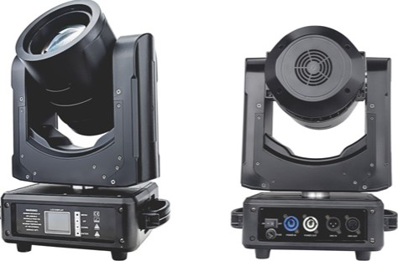 LH-C060 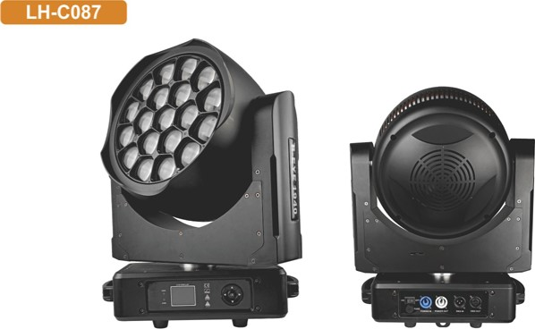

|  |  |  |  |  |  |  |  |  |  |  |  |  |  |  |  |  |  |  |  |  |  |  |  |  |  |  |  |  |  |  |  |  |  |  |  |  |  |  |  |  |  |  |  |  |  |  |  |  |  |  |  |  |  |  |  |  |  |  |  |  |  |  |  |  |  |  |  |  |  |  |  |  |  |  |  |  |  |  |  |
| --- | --- | --- | --- | --- | --- | --- | --- | --- | --- | --- | --- | --- | --- | --- | --- | --- | --- | --- | --- | --- | --- | --- | --- | --- | --- | --- | --- | --- | --- | --- | --- | --- | --- | --- | --- | --- | --- | --- | --- | --- | --- | --- | --- | --- | --- | --- | --- | --- | --- | --- | --- | --- | --- | --- | --- | --- | --- | --- | --- | --- | --- | --- | --- | --- | --- | --- | --- | --- | --- | --- | --- | --- | --- | --- | --- | --- | --- | --- | --- |
| |  |  | | --- | --- | | Model NO. | LH-C060 | | Input Voltage | ACIOO-240V 50/60Hz | | Power Consumption |  | | Light Source | 60W RGBW 4in1 LED | | Color temperature | 2700K and 3200K | | LED life expectancy | Min.20000 hrs | | Zoom range Strobe | 40 -280 | | Dimmer | Strobe effect with variable  Smooth dimmer from O— 100% | | Prism | 3—facet rotating prism with continuous rotation in both direction | | Effect | Flower effect. color rainbow effect. 3 facet prism 10 flower effect macros | | Pan | 540' (switchable to 360t 16bit | | Tilt | 270' (switchable to 3600 16bit | | Pan/Tilt | 360 degree continus rotation control | | Control mode | DMX512. master—slave, auto, sound, | | DMX channel | 27/21 CH | | Function | Beam. Wash. Spot. Small and working fast | | Product size | 290M 30*395mm | | Net weight | 9kg | | |  |  | | --- | --- | | Model NO. | LH.C087 | | power supply | 100-240V 50/60Hz | | Lamp Source | 760W | | LED Average Life | RGaw LEOS  About 50000 hours | | Zoom Range | 4.2—45degree | | Zoom Motor | 3pcs | | LED Feature | Individual LED control for each parameter | | Channel | Standard 22CH, Shapes 36CH,Pixel Engine• 36+ | | Control mode | DMX512. Master/slave, Auto. Sound | | Pan/Ti1t | Pan5400 ,16bit, Tilt 2100 .16bit | | IP Rate | IP20 protection rating | | Dimmer | O- 100% linear electronic dimmer | | Three operating modes | Wash. Beam. FX(Kaleido effects) | | Front side | Bi—directional Rotating Front Lens | | DMX signal connection | 3 Pin XLR input and output | | Power connection | Power Con In and Out | | Dimmer | O— 100% smoothly dimmer | |  | Slow Strobe: I flash/sec; Fast Strobe: 25 flash/sec, Adjustable speed stop/strobe effect | | White CT Emulation | 2500-8000K | | Net Weight | 15.7KG | | Size | 3532194.5•446 6mm | |



25 26

RGBW LED Zoom 3*40W 7pcs Led Zoom

Moving Head Light Moving Head Light

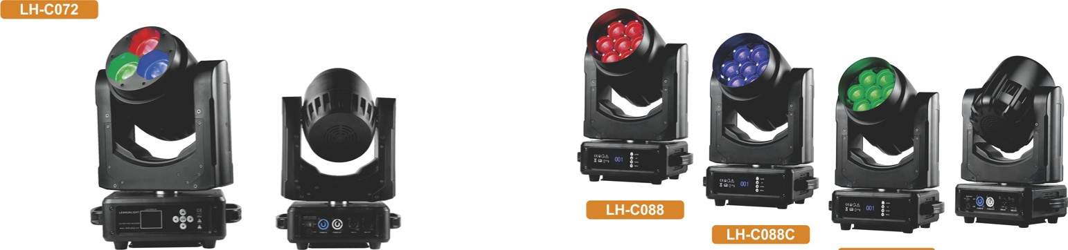

LH-C088B

|  |  |  |  |  |  |  |  |  |  |  |  |  |  |  |  |  |  |  |  |  |  |  |  |  |  |  |  |  |  |  |  |  |  |  |  |  |  |  |  |  |  |  |  |  |  |  |  |  |  |  |  |  |  |  |  |  |  |  |  |  |  |  |  |  |  |  |  |  |  |  |  |  |  |  |  |  |  |  |  |  |  |  |  |  |  |  |  |  |  |  |  |  |  |  |  |  |  |
| --- | --- | --- | --- | --- | --- | --- | --- | --- | --- | --- | --- | --- | --- | --- | --- | --- | --- | --- | --- | --- | --- | --- | --- | --- | --- | --- | --- | --- | --- | --- | --- | --- | --- | --- | --- | --- | --- | --- | --- | --- | --- | --- | --- | --- | --- | --- | --- | --- | --- | --- | --- | --- | --- | --- | --- | --- | --- | --- | --- | --- | --- | --- | --- | --- | --- | --- | --- | --- | --- | --- | --- | --- | --- | --- | --- | --- | --- | --- | --- | --- | --- | --- | --- | --- | --- | --- | --- | --- | --- | --- | --- | --- | --- | --- | --- | --- | --- |
| |  |  | | --- | --- | | Model NO. | LH.C072 | | Power Supply | ACIOO-240V 30-60Hz | | power |  | | Light source | 3•40W RGBW 4in1 LEDs mixing color | | Led feature | 3pcs LED controlled individual | | Working lifetime  Color temperature | 50000Hs | | Control Mode  Channel | DMX 512.Auto.Master—slave.Sound | | Zoom angle | 4-60' | | Dimmer | Independent dimmer channel. O— 100% linear dimmer | | Strobe | I —25times/s. speed adjustable | | pan / Tilt | Pan 540degree.TiIt:270degree ( 16bit) Electric correction | | Housing | ABS plastic* alloy | | IP rating |  | | Packing size |  | |  | 9.02kg | | Signal connect | 3—pin XLR DMX input/output | | power connect | Powercon iMout | | Display | Easy to use 5—button control panel with LCD display | | |  |  |  |  | | --- | --- | --- | --- | | Model NO. | LH-C088 | LH-C088C | LH-C088B | | Input Voltage | ACI 00-240v 50/60Hz | | | | Power Consumption | 300W | | | | Light source | RGBW 4in1 LED  +42pcs•O.2w RGB Back Color LED | RGaw 4in1 LED  +28pcs•o.2w CW Back Color LED | RGBW  4in1 LED | | Led feature | Each 6pcs 0.2w led section control | Each o.2w CW led pixel control |  | | Zoom range | 3 80 —77 Electronic Zoom Range | | | | Color temperature | 2700K and 8000K | | | | Control mode | DMX512. Master—slave. Auto. Sound | | | | DMX channel | 20/43CH | 19/50CH | 16/22CH | | Dimmer | Smooth dimmer from O— 100% | | | | Strobe | Strobe effect with variable speed | | | | Pan movement range | 5400 | | | | Tilt movement range  Function | 2700  Beam, Wash, mixing mode RGBW | | | | Product size | 290M 30 • 395mm | | | | Net weight | 10kg | | | |



27 28

150W LED spot Battery Butterfly

Moving Head Light led Light

|  |  |  |
| --- | --- | --- |
| Model NO. | 218F109 | Flogc |
| power Supply | ACI 1 ov-220V 50,'60Hz | |
| Power consumption | 20W | 25W |
| Light source | 2pcs • IOW RGBW 4in1 LED cree | 2•10VV RGaw Leds: Red Laser:50mw:  Green Laser: 50mW; UV&White Strobe:4x2w 2inI led |
| Dimmer | Linear dimmer | |
| Strobe | 0_24Hz | |
| Control mode  Channel | DMX512,  9CH | Sound.,WireIess DMX, Remote  14CH |
| Working Environment rate | IP20 | |
| Display | LED display | |
| Battery type | Lithium Ion | |
| Battery Power | 1 1 _IV 5000mAH | 11 7500mAH |
| Battery Charge Time | 3hours(fuII power) | About 4hours(aII on) |
| Battery Life  Wireless effective distance | 3hours(aII on), 7hours(singaI color)  400meters | |
| Power connector | IEC In/Out | |
| Signal connector | 3pin DMX in/out | |
| Product Size  Net Weight | 200  3.02kg | 3_25kg |

|  |  |
| --- | --- |
| Input Voltage | ACIOO-240V |
|  |  |
| Light Source | Ipc LED (white) 150W. 50.000 hours life expectancy |
| Beam Angle |  |
| Colors wheel | 7 + white.continuous scroll at variable speeds |
| Rotation wheel | 6 + open(5 aluminum + 1 glass).rotating. interchangeable. continuous scroll at variable speeds |
| Static wheel | 8 open (8 stamped). continuous scroll at variable speeds |
| Prism | a—facet round. bidirectional rotation at variable speeds |
| Dimmer | O— 100% linear dimmer |
| Strobe Rate | 0-15 Hz |
| DMX Channels | 12CH/1 SCH |
| Control mode | DMX 512. master—slave . sound , Auto |
| Display | 4—button control panel with colored LCD display |
| Cool ing | Efficient low noise fan cooling system |
| pan | 5400 movement |
|  | 270' mcwernent |
| power connector | POWERCON IN,' OUT |
| DMX connector | a—pin XLR connectors INfOlJT |
|  | 9.5Kg |

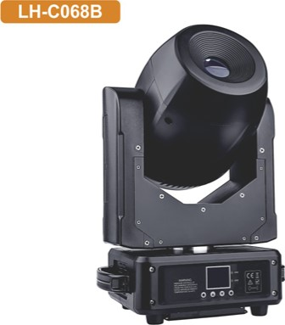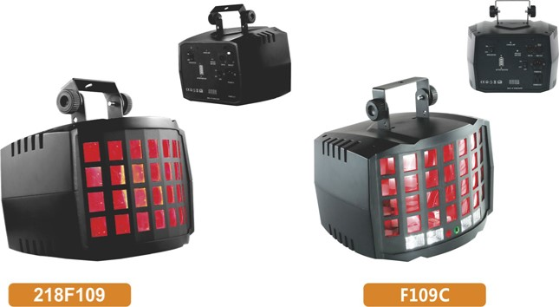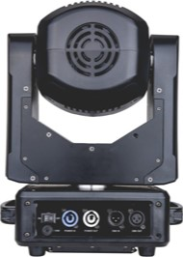Model NO.



29 30

IP65 Battery Zoom 20w Battery Lighting pole

Led Spotlights LED Spotlights

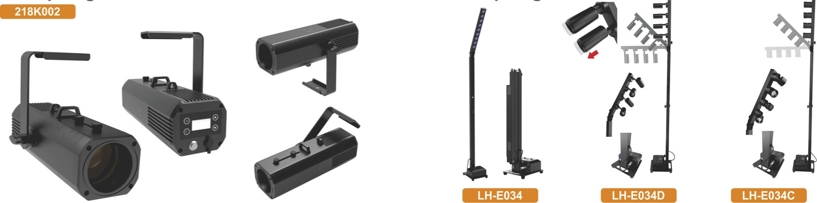

9*10W

RGBWA+UV

LED

ZOOM

|  |  |  |  |  |  |  |
| --- | --- | --- | --- | --- | --- | --- |
| Model NO. | 218K002 |  | Model NO. | LH-E034 | LH-E034D | LH-E034C |
| Input Voltage | 100-240 AC 50/60 Hz | Power Supply | ACIOO-240V/50-60Hz | | |
| Light Source | 1 LED ( white) 16 W, 1.2 A | Power consumption |  |  |  |
| Working temperature | -200 c-45' c | Light source | 9pcs LED RGBWA+LJV 6in1 | 4pcs x10w LED White | 4pcs xlOw LED White |
| Led life | 50.000 hours life expectancy | Beam Angel  Color temperature |  | Manual zoom: 17—57'  320015600K |  |
| Dimmer | 0—100% linear dimmer | Dimmer | O- 100% dimmer | | |
| Strobe | 0—24Hz, speed adjustable | Strobe rate | 0-24Hz | | |
| Zoom Angle | 160 — 31 0 (manual) | Working Environment | -20cc-40CC | | |
| Color Temperature | 6000 K | IP rate | IP20. indoor | | |
| Control mode | Master/slave.Wireless.lR remote | Channels | 6CH IOCH | 4CH / BCH | 4CH / BCH |
| DMX Channels | 1/3ch | Control Mode | DMX512.Master-slave.Sound.Auto,Wireless.lR.Wifi | | |
| Wireless Distance | 400 meters | Battery type | Lithium Ion | | |
| Display | LCD display | Battery Charge Time | Time: 6 hours | | |
| IP Rating | IP65 | Battery Life | (All on) 4 hours,  (single Color) 24hours | All on 1 Ohours | |
| Size |  | Battery power | 12V. 25Ah | | |
| Weight | 2.5 kg | Wireless distance | 400meters | | |
| Battery type | Lithium Ion | Body | Aluminium, Can be folded | | |
| Battery charge time | 2.5hours | Lighting angle | From 90-180: goo 1050 1200 1350 1500 1 650 | | |
| Battery life | 8hours | Net weight | 11 KG | | |
| Battery capacity | 12'.' 8800mAh | Product high | 17-2.3M | | |

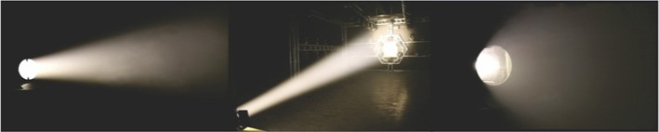

31 32

## Battery Led Pinspot zoom Battery 4x10W COB

LED Spolight BAR

|  |  |
| --- | --- |
|  |  |
| |  |  |  |  |  | | --- | --- | --- | --- | --- | | 218F091A |  | 218K035D |  | 218K035H | |

1 Leds 3Leds 6Leds

|  |  |  |  |  |  |  |
| --- | --- | --- | --- | --- | --- | --- |
| Model NO. | 218F091A | 218K035D | 218K035H |  | Model NO. | LH-K035 |
| Input Voltage | ACIOO-240V 50,'60Hz | | | Voltage | ACIOOV-240V 50-60Hz |
| power Consumption Light source | IOW  Ipcs IOW warm White LED | coa 2in1 | 6pcs IOW warm White LED | Power consumption |  |
| Led feature |  | 3• IOW Led WW.CW  More than 50000hours |  | LED  Light Color | 4pcsMOVV coa LED |
| Manual zoom Dimmer | 37 | | | Color temperature | Single color WW 3200K |
| Strobe | Linear dimmer 1-20hz,'s | | | Dimmer | 0—100% linear adjustable |
| Control mode | wreless DMX. Remote. Manual | DMX512.Master/Slave.Sound Auto.wireless dmx.remote | DMX512,  Master,'Slave.Sound Auto | Housing material | Metal |
| Housing color | Black |
| DMX Channel | 2CH | 7CH |  | Control mode | DMX512 . Master/Slave . Auto . Sound, remote |
| Working Environment | -20'c-40•c | | | DMX Channel |  |
| IP rate | 1020 | | | Working temperature | -300 c-400 c |
| Display | LED display with 4buttons | | | IP rate | IP20 |
| Housing material Housing color | Aluminum alloy Black | | | Control panel | CED display |
| Feature power input | With one strong Magnet DC charging port | With two strong Magnet Powercon IN | IEC IN/OUT | Product size Net weight: | 600x65x240mm  3.1 7kg |
| DMX connector |  | 3_pin dmx IN,/OIJT | 3-pin dmx IN,'OUT | Power input  Signal connect | Powercon IN &OUT |
| Product Size | 163x82x241mm  1.03kg |  | 959.6•74249mrn  4.06kg | Battery type | 3pin drnx in/out  Lithium Ion |
| Battery type | Lithium Ion | 2.82kg  Lithium Ion |  | Battery Power | 12V, 8800mAh |
| Battery power | 12V.5AH | 12V.8.8Ah |  | Battery lifespan | 500times circulation |
| Battery Charge Time | 3hours(full power) | 4 hours(full power) |  | Battery Charge Time | 5hours(fulI power) |
| Battery Life | All on 4.5 hours | All on 4.5hours |  | Battery Life | (All on) more than12 hours |

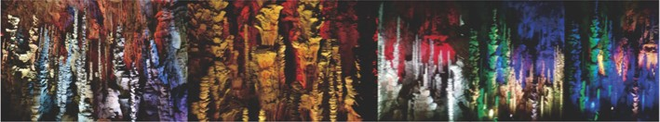

33 34

# LED COB Matrix RGBW COB

## LED Matrix

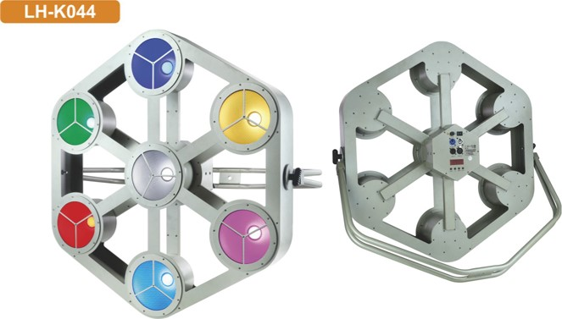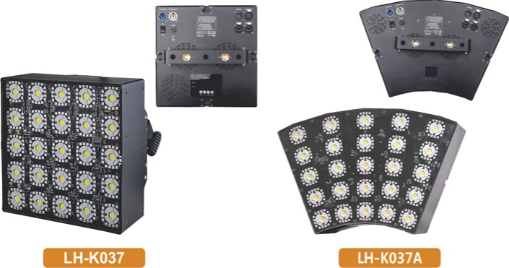LH-K037

Cube Arc

|  |  |  |  |  |  |
| --- | --- | --- | --- | --- | --- |
| Model NO. | LH-K037 | LH-K037A |  | Model NO. | LH-K044 |
| Voltage | ACIOOV-240V 50-60Hz | | Voltage | ACIOOV-240V 50-60Hz |
| Power consumption | 330W | | Power consumption | mow |
| Light source pixel | 25M Ow cold white led. each led pixel control  RGB 3in1 led, each circle pixel control | | Light source | 7pcs LED. each 30VVatt. RG3W 4in1 |
| Led Feature | Pixel control Of each LED, each color |
| LED light time | Over 50000 hours | | LED light time | over 50000 hours |
| Angle of light | 150degree | | Dimmer | 0—100% linear adjustable |
| Dimmer | O— 100% linear adjustable | | Strobe | Variable speed (1 —30Hz) |
| Strobe | Variable speed (1 —30Hz) | | Control mode | DMX512 ,Master/Slave . Auto. Sound |
| Feature | Matrix . Strobe. Blinder. Wash Effect.pixel Control | | Channel | 4/6/12/13/28/40CHs |
| Housing material | Metal | | Display | LED display |
| Housing color | Black | | Power | Powercon IN/OUT |
| Control mode | DMX512 , Artnet, Master/Slave , Auto , Sound active , RDM | |
| Channel | 112/100/12/6,'4cH | | Signal | XLR 3pin IN/OUT |
| Working temperature | -30tc-40ec | | Housing material | Metal |
| IP Rating |  | | Housing color | Silver |
| Cooling | Fan+die—casting aluminum | | Working temperature | -300C-40øc |
| Product size | 275x275x161.5mm | 453.54x299.79x161.5mm | IP Rating | IP2() |
| Net weight | 6.5KG | 7.71KG | Product size | 835.1 '75œ2258mm |



35 36

|  |  |  |
| --- | --- | --- |
| IP65 | 10*15W IP |  |
| Led Wall Washer | LED Wall Wash | Light |

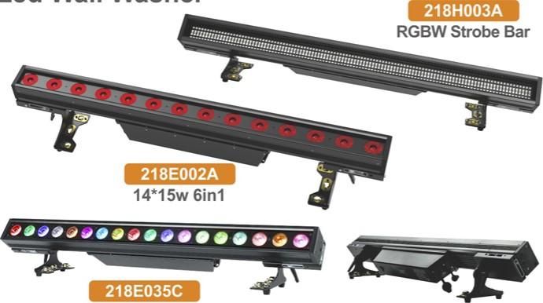218E035C 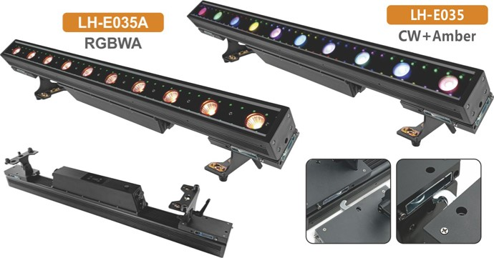

18*10w 5in1

|  |  |  |  |  |  |  |  |  |  |  |  |  |  |  |  |  |  |  |  |  |  |  |  |  |  |  |  |  |  |  |  |  |  |  |  |  |  |  |  |  |  |  |  |  |  |  |  |  |  |  |  |  |  |  |  |  |  |  |  |  |  |  |  |  |  |  |  |  |  |  |  |  |  |  |  |  |  |  |  |  |  |  |  |  |  |  |  |  |  |  |  |  |  |  |  |  |  |  |  |  |  |  |  |  |  |  |  |  |  |  |  |  |  |  |  |  |  |  |  |  |  |
| --- | --- | --- | --- | --- | --- | --- | --- | --- | --- | --- | --- | --- | --- | --- | --- | --- | --- | --- | --- | --- | --- | --- | --- | --- | --- | --- | --- | --- | --- | --- | --- | --- | --- | --- | --- | --- | --- | --- | --- | --- | --- | --- | --- | --- | --- | --- | --- | --- | --- | --- | --- | --- | --- | --- | --- | --- | --- | --- | --- | --- | --- | --- | --- | --- | --- | --- | --- | --- | --- | --- | --- | --- | --- | --- | --- | --- | --- | --- | --- | --- | --- | --- | --- | --- | --- | --- | --- | --- | --- | --- | --- | --- | --- | --- | --- | --- | --- | --- | --- | --- | --- | --- | --- | --- | --- | --- | --- | --- | --- | --- | --- | --- | --- | --- | --- | --- | --- | --- | --- | --- | --- |
| |  |  |  |  | | --- | --- | --- | --- | | Model NO | 218E035C | 218E002A | 218H003A | | Input Voltage | ACIOO-240V 50-60Hz | | | | Power | 1 BOW | 210W | 350" | | LED light source | 18 x IOW RG3WY Sinl LED | 14x 15W RGBWAP LED (6in1) | RGB LEDs CW LEOS  448 | | Led Feature | Each I-EDS can be controlled individually;Excellent color mixing capabilities | Each LEDs can be controlled individually:Excellent color mixing capabilities | 32 zones of RGB can be controlled 16 zmes of cold white  color mixing capabilities | | Life Time | 20000 hours | | | | Beam Angle |  |  |  | | Dimmer | 0—100% smooth dimming | | | | Strobe | 0—20Hz strobe. speed adjustable | | | | Control mode  DMX Channel | DMX512. Master—slave.  Auto, ROM  ICH / SCH / 90CH 93CH | DMX512. Master/slave.  Auto.RDM.Art-Net | DMX512. Master—slave.  Auto. ROM  7/13QIW1171 17/70CH | | IP Rate | BCH | | | | Working temperature |  | | | | Control panel | OLED display with 4 button | | | | Power in/out | 1965 Power Connector In/Out | | | | DMX input/output Product size | IP65 3pin XLR DMX nput.'output |  | IP65 3pin XLR DMX input/output | | Net weight |  | 9.2 kg |  | | Fixture feature | "—side can achieve seamless splicing | | | | Software upgrades | Update software via DMX connection | | | | |  |  |  | | --- | --- | --- | | Model NO. | LH-E035A | LH-E035 | | Voltage | ACIOO-240V 50-60Hz | | | Power Draw | 200W | | | LEDs | Pixel 10pcs 15W RGBCW LED + 80*0.2W RGB 3in1 | Pixel 10pcs 15VV CW  *Amber LED + 80*O.2W RGB SMD LED | | Beam Angle | 360 | | | Control mode | 512DMX, Master—slave, Auto, Sound | | | Feature | Each led controlled individual. pixel control,each 4pcs small led section control | | | Life Time | 50,000 hours | | | DMX Channel | ICH /8CH/12CH/1 IOCH/113CH | ICH / 5CH / BCH / 80CH / 83CH | | Dimmer | O— 100% with regulated constant color control | | |  | 10 Flashes per second (any color) | | | Waterproof rate | IP65 | | | Cover | Aluminum | | | Size | 100M6'21CM | | | Net weight | 7.4KG | | | Installation features | Seamless connection Of each side | | |



37 38

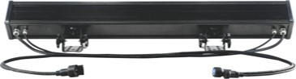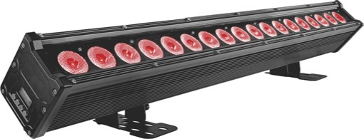18*10W RGBW IP

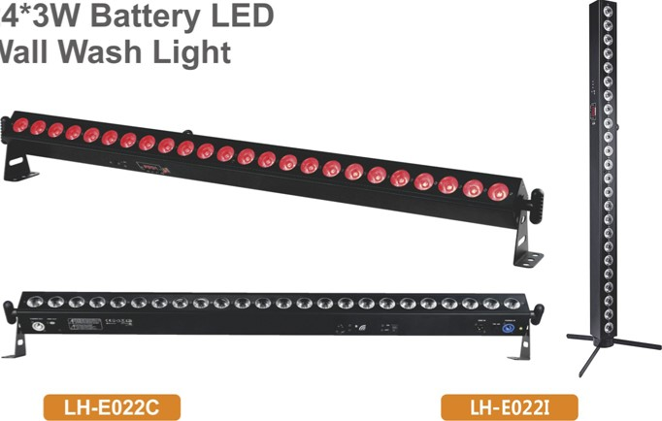

24*3W

Wall

24*3W

RGB

24*3W

RGBW

## LED Wall Wash Light

LH-E046

|  |  |  |  |  |  |  |
| --- | --- | --- | --- | --- | --- | --- |
| Model NO. | LH-E046 |  | Model NO. | LH-E022C | LH-E0221 | |
| Input Voltage | 90-240 VAC 50-60Hz | Power Supply  Power consumption | AC 100-240V/50-60Hz gow | | |
| power |  | Light source | 24pcs•3W LED RGB 3in1 mixing color | 24pcs•3W LED RGBW 4in1 mixing color | |
| Light Source | 18MOW RGBW 4in1 LEDs | LED Feature | with 1/214/8 zones of individual control | with 2/8 zones of individual control | |
| Control Mode | DMX512. Auto, sound, Master/Slave | Beam Angle Dimmer | 10/20/25degree(optional)  0-100% | dimmer |  |
| DMX Channels | 9/27/72/81 CH | Strobe rate | 0-24HZ |  |  |
| Dimmer | 0-100% linear 8/16Bit Dimminr | Working Environment  IP rate |  | -200C-40CC  IP20 |  |
| Shutter/Strobe | Electronic | DMX Channels | 5/8/14/26,'50CH |  | 6/8'14/50CH |
| Strobe Rate | 0-20 Hz | Control Mode Control panel | LCD | display | wireless |
| Housing | Die—casting aluminium housing | Product size |  | 1072x74.6x120.5mm |  |
| Beam Angle |  |  | 3_47KG |  |  |
| Battery type | Lithium | Ion |  |
| IP Rating |  | Battery lifespan | 500times | circulation |  |
| Data Connectors | 3pin Dmx cable in/out | Battery Charge Time | 6hours(fuII | power) |  |
| Power Connectors | Power cable in/out | Battery Life  Battery power | (All on) 4.5hours.(single Color) 12 hours (All on) Color) 16 hours 12M 16000Ah | | |
| Net Weight | 7_59kg | Wireless effective distance | 400meters | | |
| Dimensions |  | Charging  Charge full | Light red on Light Off | | |



39 40

## LED Wall Wash Light

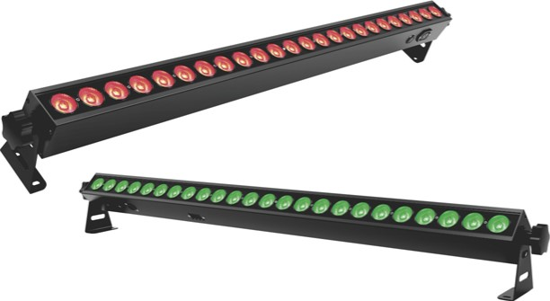

|  |
| --- |
| LH-E018E |

### LH-E018D 24*3w RGB 24*4W RGBW

RGBW LED

City Color Light IP

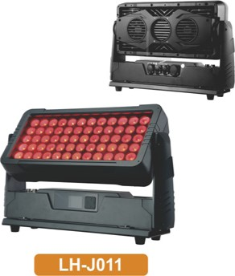LH-JOII 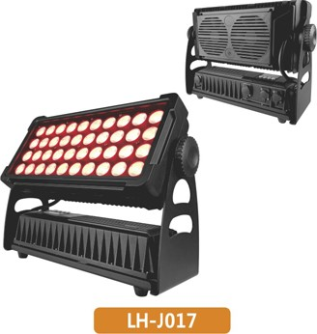LH-J017 60*10W 40*10W



|  |  |  |  |  |  |  |
| --- | --- | --- | --- | --- | --- | --- |
| Model NO. | LH-E018E | LH-E018D |  | Model NO. | LH-JOII | LH-J017 |
| Input voltage | ACI 10-240V 50-60Hz | | Power supply | ACI 00-240v 50/60Hz | |
| power | 1 oow | | Power | 600th/ | 480W |
| Light source | 24pcs 3W RGB 3-IN-I LED | 24pcs 4wRGBW 4in1 LED | Lamp Source | 60pcs IOW RGBW 4-IN-I LED | 40x10w RGBW LEDs |
| Feature | Small size, high power, super brightness,colour mixture | |
| LED feature | 8 sections LEDs control | | Function |  | With RDM function |
| Lens angle | 25degree | | LED Average Life | 50,0000H | |
| Channel | 7/24CH | 8,'32CH | Beam Angle | 400 | |
| Control mode | DMX512, Master—slave, Auto, Sound, Remote | | IP rate | IP65 | |
| Life Time | 50.000 hours | | Dimmer | 0—100% linear electronic dimmer,no flicker | |
| Strobe | Adjustable speed stop/strobe effect, with instantaneous blackout | |
| Dimmer | O— 100% with regulated constant color control | | Operating modes | DMX512, Master/slave. Auto | |
| Strobe | 0-24Hz | | DMX channels | 4/5/9CH | 4/8CH |
| Display | LED display | | Display | Easy-to—use 4—button control panel with LCD display | |
| Signal data | 3pin XLR in/out | | Power connect | Powercon in/out | |
| Power connect | IEC in/out | | Signal connect | 3-pin XLR DMX input/output | |
| Net weight | 1.96kg | | Cover: | Aluminum | |
| Net Weight | 15KG |  |
| Product size | 101 Ox65x65 mm | | Size |  | 450M31'310mm |

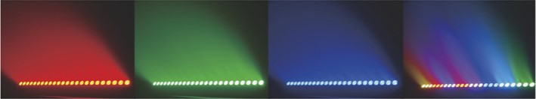

41 42

|  |
| --- |
| LH-D068D |

# 7*40W RGBW +RGB LED Par Zoom Light IP LED Par Zoom Light IP

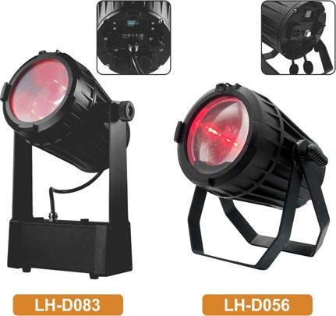

cOW

LED

LH-D078 LH-D083

3pcs*40W LED 3pcsuow LED

|  |  |  |  |  |  |  |
| --- | --- | --- | --- | --- | --- | --- |
| Model NO. | LH-D068D |  | Model NO. | LH-D078 | LH-D083 | LH-D056 |
| Input Voltage | AC90-260V 50,'60Hz | Power Supply | ACIOO-240V/50-60Hz | | |
| Light Source | 7pcs 40w4-lN-1 LEDs (R. G. B. W)  +96pcsxO.2w RGB SMD | Power consumption | 120th/ | 120th/ |  |
| Light Source | 3'40W RGBW 4in1 | 3'40W RGBW 4in1 | Ipcs 60w RGBW 4inl |
| power Consumption | 280W | Zoom Angle | 70 — | 70 — | 60 -540 |
| Zoom range | 3—60degree | Lumen | 12700 Lux (3m) | | |
| Zoom Motor | 2pcs | Dimmer | 0—100% dimmer | | |
| Channel | 9/19CHS | Strobe rate | 0-24Hz | | |
| Control mode | DMX512, master—slave, Auto | Working Environment | -200C-400C | | |
| Life time | 60000hours | IP rate |  | | |
| Dimmer | O— 100% smoothly dimmer | DMX Channels | 17/12/9CH | | 8/12CH |
| Strobe | 20t]s strobe effect with variable speed |
| IP rate | IP65 protection rating | Control Mode | MX512.Sound,  Auto. Master-slave | 512, ound, to,  Master-slave Wireless DMX | MX512, Sound,  Auto Master—slave |
| Power connect | Seetronic Power In/out | Battery type |  | Lithium Ion |  |
| Signal connect | 3Pin XLR DMX input/output | Battery Charge Time Battery Life |  | 7 hours(full power)  20nrs |  |
| Display  Product size | Touching Screen  291 •238•266mm | Battery Power |  | 22.2V, 12.5Ah |  |
| N.W. | 9.1kg | N.W. | 4.6kg |  | 4.6kg |



43 44

|  |  |  |
| --- | --- | --- |
| LH-D043RA |  | LH-D043RB |

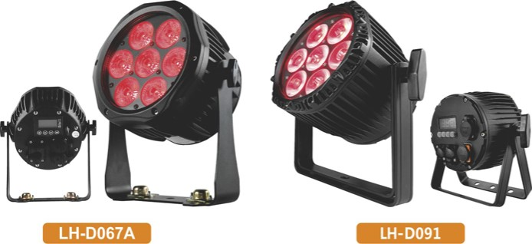7pcs RGBWA+UV

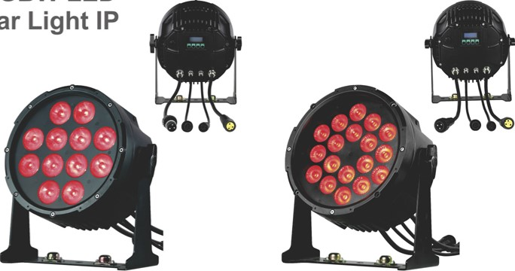

RGBW

LED

Par

# LED Par Light IP

## 12pcs*10W 18pcs*10W

|  |  |  |  |  |  |  |
| --- | --- | --- | --- | --- | --- | --- |
| Model NO. | LH-D067A | LH-D091 |  | Model NO. | LH-D043RA | LH-D043RB |
| Power supply | ACIOO-240V 50,'60Hz | | power Supply | AC 100-240V/50-60Hz | |
| Power |  | | Power consumption | 1 sow | now |
| Lamp Source | 7pcs*12W RGBWA+IJV 6in1 LED | |
| Feature | Small size, colour mixture | | Light source | 12x10W RGBW 4in1 LED | 18x10W RGBW 4in1 LED |
| LED Average Life | 50.000H | | Beam Angle | 1 50 | |
| Beam Angle |  | | Dimmer | 0—100% dimmer | |
| IP rate | IP65 | | Strobe rate | 0-24HZ | |
| Dimmer | O— 100% linear electronic dimmer | | Working Environment | -200c-40CC | |
| Operating mode | DMX512. master/slave. auto.sound | |
| Channels | 6/1 OCH | | IP rate | IP65,outdoor | |
| Display | With LCD display | With LED display | DMX Channels | 4/9CH | |
| Function | Can make magic, color mixed, charming effect | | Control Mode | DMX512, Master-slave, Sound,Auto | |
| Signal connect | 3—pin XLR DMX input/output | | Display | LCD display with 4 touch button | |
| Power connect | Power In and Out | | Net weight | 5.7kg | |
| Net Weight | 3.1KG | |
| Size |  | 250+170*230mm | product Size | 286m mx 148mmx290m m | |



45 46

|  |  |
| --- | --- |
| 18pcs IP | 12pcs LED |
| LED Par | Battery IP LED Par Light |

|  |  |  |
| --- | --- | --- |
| LH-D043T |  | LH-D043W |

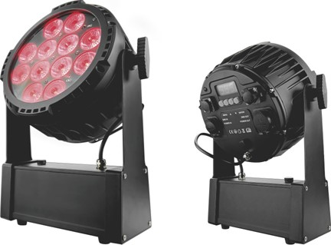 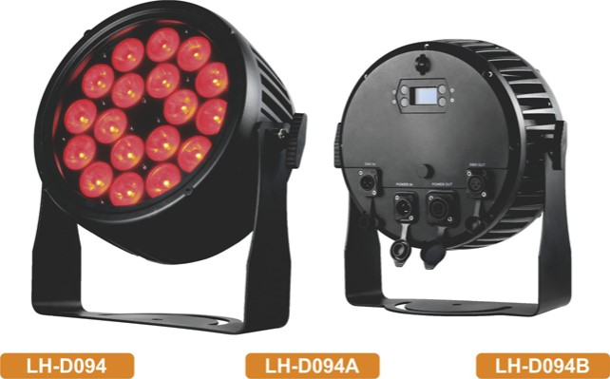 RGBWA 5in1 RGBWA+UV 6in1

|  |  |  |
| --- | --- | --- |
| Model NO. | LH-D043T | LH-D043W |
| Voltage | ACIOO-240V 50Hz-60Hz | |
| Consumption | 120W | 1 sow |
|  | 12pcs IOW RGBWA 5in1 LED | 12pcs 12W RGBWA+IJV 6 inl LED |
| Channel | 5CH/9CH | 6CH/10CH |
| IP rate |  | |
| Mode of control | DMX512, Auto , Master—slave, Wireless, Wifi, Remote | |
| Function | Can make magic, color mixed, charming effect | |
| Size | 70kg | |
| Battery type | Lithium Ion | |
| Battery Power | 12V. 25000mAh | |
| Battery lifespan | SOOtimes circulation | |
| Battery Charge Time | 8hours(full power) | |
| Battery Life | (All on) I I hours, (Single Color) 30 hours | |
| Battery charging | Red on, charging full : Green on | |
| Battery display | Long press Menu 3s, Will see the battery indicator | |
| Wireless effective distance | 400meters | |

|  |  |  |  |  |
| --- | --- | --- | --- | --- |
| Model NO. | LH-D094 | LH-D094A | LH-D094B |  |
| Power Supply | ACIOO-240V 50-60Hz | | |  |
| power consumption |  | 250W | 200vv |  |
| Light source | 18x2w,/ RGBWA W enl LED | 18x12W RGBW 4in1 LED | 18x10ARG3WA | LED |
| LED lifespan | 20.OOOhours | | |  |
| Beam Angle | 250 | | |  |
| Dimmer | dimmer | | |  |
| Strobe rate | 0-24HZ | | |  |
| Working Environment | -20ec-40ec | | |  |
| IP rate | IP66.outdoor | | |  |
| Control Mode | DMX512, Master—slave,Sound,Auto, RDM | | |  |
| DMX Channels | 6/8/12CH | 4/6/1 OCH | 6/8/12CH |  |
| Display | Easy to use 4 buttons to control panel with LCD display | | |  |
| Signal connect | Waterproof 3pin XLR DMX input&output | | |  |
| Power connect | Powercon In/out | | |  |
| Net weight | 6_42KG | | |  |

Product size



47 48

# IP

## Led Par light

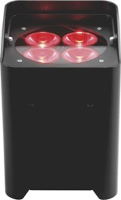

LH-D050A

4pcs Led

|  |  |  |  |
| --- | --- | --- | --- |
| Model NO. | LH-D050A | LH-D050F | LH-D050H |
| Power Supply | ACIOO-240W50-60Hz | | |
| Power consumption |  |  |  |
| Light Source | 4x12W RGBWA  +1JV 6in1 LED | 6x12w RGBWA  +1JV LED | 9x10W RGBW  4in1 LED |
| Beam Angle | 250 | | |
| Dimmer | O— 100% dimmer | | |
| Strobe rate | 0-24HZ | | |
| Working Environment | -200C-40cc | | |
| IP rate | IP65,Outdoor | | |
| DMX Channels  Control Mode | 7CH 1 ICH | 7CH / 1 ICH | 4CH / BCH |
| Battery type | DMX512. Master—slave. Remote  Lithium Ion | | |
| Battery Charge Time | 4.5 hours(full power) | | |
| Battery Life | (All on) 6hours, (single Color) 30hours | | |
| Battery Power | 12". 13.2Ah | 12V.13.2Ah | 12V.10Ah |
| Wireless effective distance | 400meters | | |
| Product size | 140M40•200mm | | |
| Net weight | 2.97kg | 3.08kg | 3.08kg |

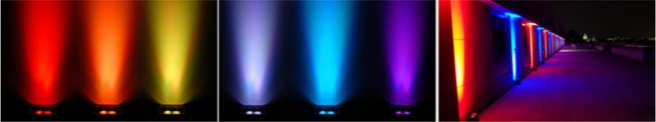RGBWA+UV 6in1

49

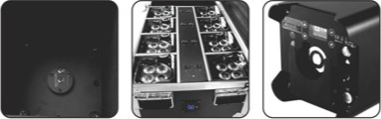

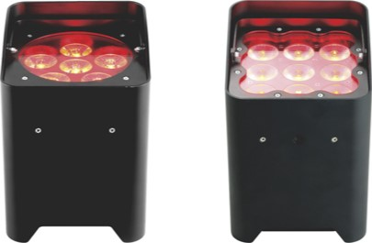

|  |  |  |
| --- | --- | --- |
| LH-D050F |  | LH-D050H |

6pcs Led 9pcs Led

RGBWA+UV 6in1 RGBW 4in1

Battery Led Par light 9pcs

Led 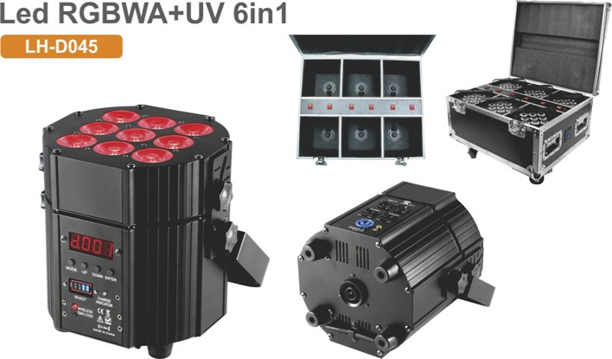RGBWA+UV 6in1

|  |  |
| --- | --- |
| Model NO. | LH-D045 |
| Power Supply | ACIOO-240V/50-60Hz |
| Power consumption | 1 IOW |
| Light source | 9pcs 12VV LED RGBWA+UV 6in1 mixing color |
| Beam Angle | 150 |
| Dimmer | O- 100% dimmer |
| Strobe rate | 0-24HZ |
| Working Environment | -200C-400C |
| IP rate | IP20,indoor |
| DMX Channels  Control Mode | 2 DMX modes, 6channels mode & 10 channels mode |
| Battery type | DMX512,  Lithium Ion |
| Battery Charge Time | 6 hours(full power) |
| Battery Life | (All on) 4hours. (single Color) 30hours |
| Battery Power | IN. 25Ah |
| Wireless effective distance | 400meters |
| Product size | 222.5M83ff260MM |
| Net weight | 4.5kg |

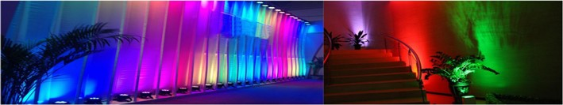

50

## LED Par Battery LED Par Light

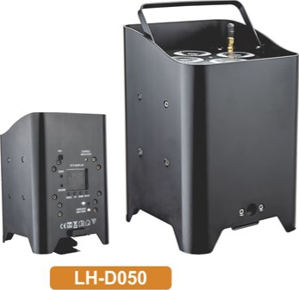LH-D050 LH-D050E LH-D053 LH-D060

4pcs LED 6pcs LED RGB 3in1 RGBW 4in1

|  |  |  |  |  |  |  |
| --- | --- | --- | --- | --- | --- | --- |
| Model NO. | LH-D050 | LH-D050E |  | Model NO. | LH-D053 | LH-D060 |
| power Supply | ACIOO-240V,'50-60Hz | | power Supply | ACIOO-240W50-60Hz | |
| Power consumption |  |  | Power consumption |  | gow |
| Light source | 4pcs•12W LED RGBWA+UV 6in1 mixing color | 6 • 12 W RG3WA+UV 6in1 LED | Light source | 3pcs•3w LED RGB 3inl mixing color | 3pcs•lOw LED RGBW 4in1 mixing color |
| Beam Angle | 150 | 250 (optional) | Beam Angle | 10/25 degree | 20 degree |
| Dimmer | O— 100% dimmer | | Dimmer | dimmer | |
| Strobe rate | 0-24HZ | | Strobe rate | 0-24HZ | |
| Working Environment | -20•c-40cc | | Working Environment | -20ec-4(fi; | |
| rate | IP20.indoor | | IP rate | IP20 | |
| DMX Channels | 2 DMX modes. 6channels mode & 10 channels mode | | DMX Channels | 7 channels | |
| Control Mode | DMX512.Master-slave.Sound.Auto.Wreless.Wfi. Remote | | Control Mode | DMX512. Master—slave.Sound.Auto .remote | |
| Battery type | Lithium Ion | | Remote | IRC remote | |
| Battery Charge Time | 3 hours(full povver) | | Battery type | Lithium Ion | |
| Battery Life | (Al on) 6hours. (single Color) 36hours | | Battery Charge Time | 6hours(fuII power) | |
| Battery power | 1 w. 8800mAh | | Battery Life | (All on) 8hOurs, (single Color) 24hours | |
| Wireless effective distance | 400meters | | Battery Power  IEC power | 12 V. 5000mAh | |
| Product size  Net weight | 2.4kg | | DMX control | In/Out(charging) apin In/Out | |
| Housing | Black | | Charging indicator | Red | |
| Charging | Charging in flightcase or cable | | Charging full indicator | Green | |



51 52

## LED Par 19Leds Led Par Zoom

RGBWA+UV 6in1

ease ßee

|  |
| --- |
| LH-D061A |

LH-D073

4pcs LED 4pcs LED

|  |  |  |  |  |  |  |  |  |  |  |  |  |  |  |  |  |  |  |  |  |  |  |  |  |  |  |  |  |  |  |  |  |  |  |  |  |  |  |  |  |  |  |  |  |  |  |  |  |  |  |  |  |  |  |  |  |  |  |  |  |  |  |  |  |  |  |  |  |  |  |  |  |  |  |  |  |  |  |  |  |  |  |  |  |  |  |  |  |  |  |  |  |  |  |  |  |  |  |  |  |  |  |  |
| --- | --- | --- | --- | --- | --- | --- | --- | --- | --- | --- | --- | --- | --- | --- | --- | --- | --- | --- | --- | --- | --- | --- | --- | --- | --- | --- | --- | --- | --- | --- | --- | --- | --- | --- | --- | --- | --- | --- | --- | --- | --- | --- | --- | --- | --- | --- | --- | --- | --- | --- | --- | --- | --- | --- | --- | --- | --- | --- | --- | --- | --- | --- | --- | --- | --- | --- | --- | --- | --- | --- | --- | --- | --- | --- | --- | --- | --- | --- | --- | --- | --- | --- | --- | --- | --- | --- | --- | --- | --- | --- | --- | --- | --- | --- | --- | --- | --- | --- | --- | --- | --- | --- | --- |
| |  |  |  |  | | --- | --- | --- | --- | | Model NO. |  | LH-D061A | LH-D073 | | Power Supply |  | ACIOO-240V,SO-60Hz |  | | power consumption |  |  |  | | Light source |  | 4pcs• 12W LED RGBWA+IJV | Sinl mixing color | | Beam Angle |  | 150 |  | | Dimmer |  | 0—100% | dimmer | | Strobe rate |  | 0-24HZ |  | | Working Environment |  |  |  | | IP rate |  | IP20. | indoor | | DMX Channels | 3CH, | BCH. IOCH | 6CH IOCH | | Control Modes |  | DMX. Master—slave. | Sound.Auto. Remote | | Battery type | Lithium Ion | | | | Battery Charge Time | 6 hours (full power) | | 6 hours(full power) | | Battery Life | (All on) Shours. (single Color) 12hours | | (all on)5hours. (single Color) 12hours | | Battery Power | 12V. 6600mAh | | 1 2V. 8800mAh | | Product size | 140M40•145mm | |  | | Net weight | 185kg | | 2kg | | |  |  | | --- | --- | | Model NO. | 218D049F | | Input Voltage | AC90-260V 50/60Hz | | power Consumption | 300W | | Light Source | 19pcs 15w 4-IN-I LEDs (R, G, B, W) | | Led Feature | 3zones control individual | | Zoom range | 15—60degree | | Control mode | DMX512, master— slave, Sound,Aut0 | | Channel | 10/18/6CHs | | Dimmer | O— 100% smoothly dimmer | | Strobe | 20t/s strobe effect with variable speed | | Cooling | Low noise and efficient FAN cooling system | | IP rate | IP20 protection rating | | Signal | 3-Pin XLR DMX input/output | | power | Powercon in out | | Display | LED display | | Net weight | 4.9kg | | packing size | 280'280'390mm( Ipcs/CTN) | |



53 54

|  |  |
| --- | --- |
| 1 oow ZOOM | LED Spotlights |

## LED Par

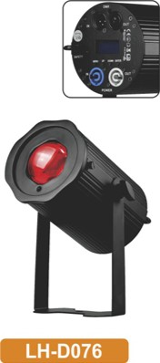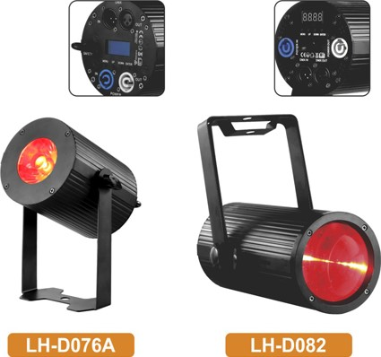 LH-D076 LH-D082

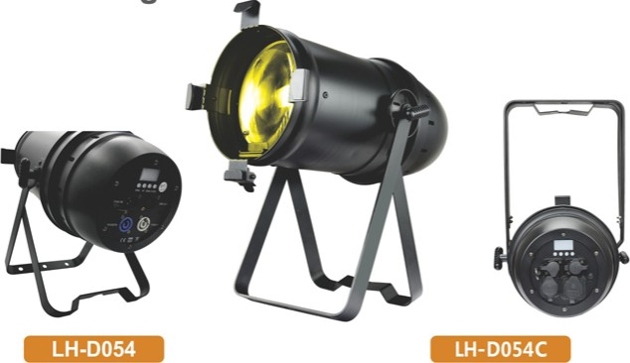

IP20

IP54

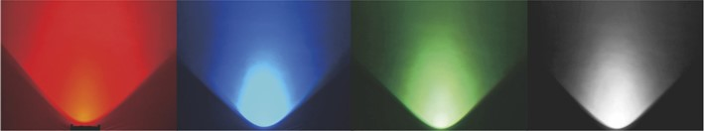 40W Manual Zoom 40W cOW Manual Zoom

|  |  |  |  |  |  |  |  |  |  |  |  |  |  |  |  |  |  |  |  |  |  |  |  |  |  |  |  |  |  |  |  |  |  |  |  |  |  |  |  |  |  |  |  |  |  |  |  |  |  |  |  |  |  |  |  |  |  |  |  |  |  |  |  |  |  |  |  |  |  |  |  |  |  |  |  |  |  |  |  |  |  |  |  |  |  |  |  |  |  |  |  |  |  |  |  |  |  |  |  |  |  |  |  |  |  |  |  |  |  |  |  |  |  |  |  |  |  |  |  |  |  |  |  |  |  |  |
| --- | --- | --- | --- | --- | --- | --- | --- | --- | --- | --- | --- | --- | --- | --- | --- | --- | --- | --- | --- | --- | --- | --- | --- | --- | --- | --- | --- | --- | --- | --- | --- | --- | --- | --- | --- | --- | --- | --- | --- | --- | --- | --- | --- | --- | --- | --- | --- | --- | --- | --- | --- | --- | --- | --- | --- | --- | --- | --- | --- | --- | --- | --- | --- | --- | --- | --- | --- | --- | --- | --- | --- | --- | --- | --- | --- | --- | --- | --- | --- | --- | --- | --- | --- | --- | --- | --- | --- | --- | --- | --- | --- | --- | --- | --- | --- | --- | --- | --- | --- | --- | --- | --- | --- | --- | --- | --- | --- | --- | --- | --- | --- | --- | --- | --- | --- | --- | --- | --- | --- | --- | --- | --- | --- | --- | --- | --- |
| |  |  |  | | --- | --- | --- | | Model NO. | LH-D054 | LH-D054C | | Input voltage | AC 100-240V 50-60Hz | | | Power | 105W | | | Light Source | Ix100w COB warm white/Cold white LED | | | Color temperature | 100 VWV 3000K] 100 CW 5700K | | | Life Time | 50,000 hours | | | Beam Angle | 90 115' 1200 1250 1300 . can be manually switched | | | CRI |  | | | Channel | 1/2CH | | | Control Mode | DMX512.Manual | | | Protection Rating | IP20 | I P54 | | Dimmer | O— 100% linear dimmer | | | Strobe | 10 Flashes per second | | | Cover | Aluminum | | | Data In/Out | 3pin DMX In/out | | | Power In/Out | Powercon in/out | | | Size | 564•281 •224mm | | | N.W. | 3.58kg | | | High brightness , energy saving, can replace the traditional 1000W par lights | | | | |  |  |  |  | | --- | --- | --- | --- | | Model NO. | LH-D076 | LH-D076A | LH-D082 | | Voltage | ACIOO-240V 50Hz-60Hz | |  | | Consumption | sow | | BOW | | Light Source | 1 RGBW 4in1 LED | | 60W RG3W 4in1 LED | | Channel  Mode of control | DMX512, Auto, Sound, | | DMX512,Auto, Sound, Master-slave | | Beam Angle |  | 50 |  | | Zoom range | 4—600 (manual zoom) |  | 4—600 (manual zoom) | | Dimmer | 0—100% dimmer | |  | | Strobe rate | O-20HZ | |  | | Working Environment | -20CC-400C | |  | | IP rate | IP20 | |  | | Function | Manual zoom,  Beam Wash effect |  | Manual zoom,  Beam Wash effect | | Power connect | PowerCon in/out | |  | | Signal connect | 3-pin XLR in/out | |  | | Net weight | I .4KG | 1.24KG |  | | Product size | 160M30*270mm | 165*118'233.9mm |  | | 3modes mounting |  |  | Clamp to fix on truss,  Pendant, Recess Ceiling | |

56

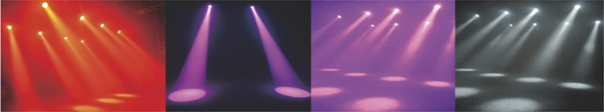

/

rMM/(

55

200W WW+CW COB 6in1 Led Par Light

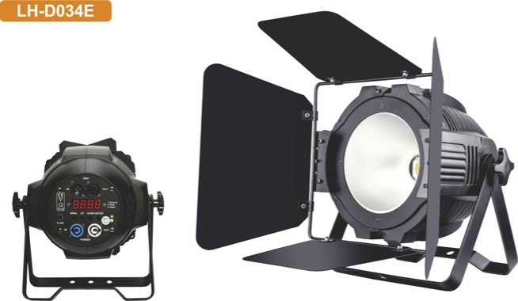LED Par

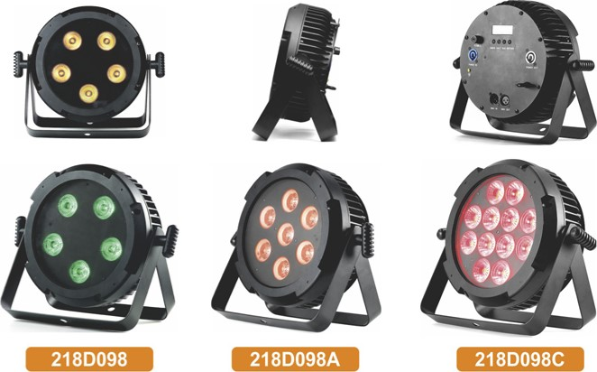

5Leds

7Leds

12Leds

|  |  |  |  |  |  |  |
| --- | --- | --- | --- | --- | --- | --- |
| Model NO. | LH-D034E |  | Model NO. | 2180098 | 218D098A | 218D098C |
| Voltage | ACI 10-220V 50-60HZ | Voltage | 90-260V 50/60Hz | | |
| Power  Light source | 250W  Warm white IOOW+COOI white IOOw 2in1 | Power | 60W |  | 120th/ |
| Color temperature | 2000k -6500k | Light source | 5x10W rgbwauv 6 inl LED | rgbwauv 6 inl LED | 12x10W rgbwauv 6 inl LED |
| LED Life Time | over 50000hours | LED life |  | 50. 000 hours |  |
| IP Grade | IP20 |
| Environment Temperature | -30B -450 | Lens degree | 150 ,25' ,456 (Optional) | | |
| Housing Color | Black | DMX channel |  | | |
| Light body Barndoor | Die—casting Aluminum With barndoor | Control Mode | DMX512 . Master—slave *Auto . Sound, Remote | | |
| Dimmer | 0—100% linearly adjustable | Dimmer | O— 100% linear dimmer | | |
| Control Mode | DMX512/Master—slave/Sound activated/Auto mode | Strobe | 20t/s strobe effect with variable speed | | |
| Channel  LED angle | 2/4,'6CH | IP Rate | IP20 | | |
| Setting and Addressing | 4—digit | Display | LED display with 4buttons | | |
| LED Cooling Fan Noise | Forced Air Convection, with 1 Fan  12.1-20dB | power | Powercon in/out | | |
| Fan speed | 900-2.000RPM ± 10% | Signal | 3pin XLR DMX in/out | | |
| Technology  rate | Thermal management system ensures 10 life of LED | Product dimension |  | 300'272M08mm |  |
| Refresh  Packing Size | 4000Hz. flick free for and Studio case) | N.W. | 3.7KG | 3.788KG | 3.826KG |



57 58

|  |  |
| --- | --- |
| 1260pcs CW+WW | IOOw Led Fresnel |
| Led Panel Light | SpotLight with zoom |

LH-K055 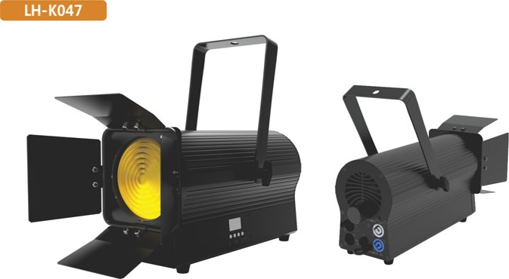

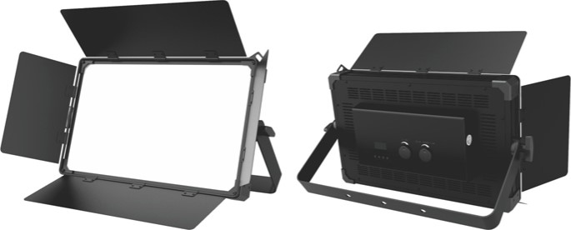

|  |  |  |  |  |
| --- | --- | --- | --- | --- |
| Model NO. | LH-K055 |  | Model NO. | LH-K047 |
| Input voltage | AC 100-240V 50,'60Hz | Input voltage | AC 100-240 V 50/60 Hz |
| power |  | Power | 1 oow |
| Light source | 630 cool white + 630 warm white LED lamp beads | Light source | IOOW COB warm white |
| Color temperature | 3200 ± 200K-5600 ± 200K | Zoom Angle | 106 —650 ,manual zoom |
| Feature | Flicker—free under HD cameras | Featu re | Flicker—free under HD cameras |
| CRI | CRI>92 | LED life expectancy | 20000 hours |
| LED life expectancy | 20000 hours | Color temperature | 3200± 100K |
| Display | LCD display, 4 mechanical buttons, 2 knobs |  | 89.7 |
| Control protocol | RDM, DMX, master/slave | Display | LED display, 4 mechanical buttons |
| DMX channel mode | 6 modes | Control protocol | RDM, DMX512, master/slave |
| IP rate | IP20 | DMX channel mode | 1 mode |
| power Connector | Powercon I n/Out | IP rate | IP20 |
| Signal Connector | 3—pin XLR in/out | Power Connector | Power con in/out |
| Product size | 558• 101 • 348mrn(Length• Width• Height) | Signal Connector | 3—pin XCR in/out |
| Net weight | IO_5kg | Product size | 356M 72' 188mm(Length'Width'Height) |



59 60

|  |  |
| --- | --- |
| 380w BSW 3in1 | Mini now 7R Beam |
| Moving head | Moving Head Light |

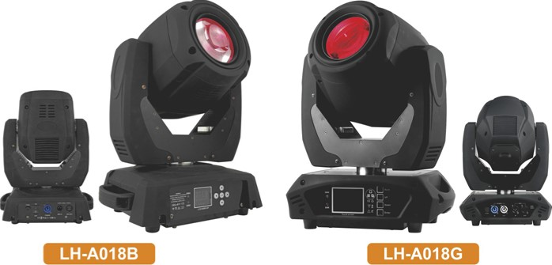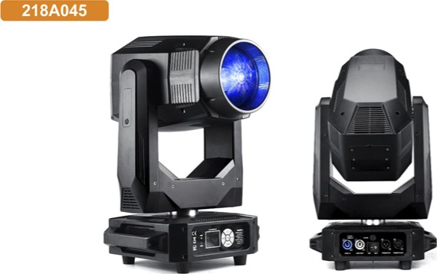218A045

|  |  |
| --- | --- |
| Model NO. | 218A045 |
| Power supply | 100-240V SO,'60Hz |
| power |  |
| Lamp source | 380W lamp |
| Color temperature | (white ligh07100K |
|  | 71 |
| Zoom Angle  Dimmer | O— 100% linear electronic dimmer |
|  | 0-20Hz |
| Colors wheel | 9 color*blank |
| Fixed Gobo wheel | 9 gobos•blank |
| Rotate Gobo wheel | 7 gobos•blank |
| Prism | Prism I : 3 prism rotation. prism 2: 6 Prism rotation. 2prism can overlap |
| Frost | Independent frost effect |
| Control mode | DMX512. master/sLave. auto.sound |
| Channel | 16,Q4CH |
| Display | Easy—to—use 4—button control panel with LCD display  . |
| Power | pan :540' . 16bit  Pcmercon In/Out |
| Signal | 3pin XLR DMX in,'out |
| Net Weight | 15.7KG |

|  |  |  |  |  |
| --- | --- | --- | --- | --- |
| Model NO. | LH-A018B | | | LH-A018G |
| power Supply | ACI 1 ov-240V 50/60Hz | | | |
| Power | 260W | | | |
| Light source | IR 230w lamp | | | |
| Ballast | Electronic ballast | | | |
| Housing | ABS plastic*alloy | | | |
| Color | Black | | | |
| Lens | 6—Layer option glass lens | | | |
| Beam an le | 0_3.8' | | | |
| Channel | 17CH | | | 16 / 20CH |
| Working lifetime(Hour) | 2000Hs.lP20 (for indoor use only) | | | |
| Color temperature | 8000K | | | |
| Size | 12KG | | | 335•225• 435mm  1 1 .9 |
| Dimmer |  | ndent dimmer channel. 0—100% linear dimmer | | |
| Strobe | Inde endent strobe channel. 1—13times/s. s eed adustable | | | |
| Prism | 16 Facet Rotati | | rism | 8 Facet rotating prism |
| Gobo | 14 Obos+blank double rotation rainbow effect | | | |
| Colors | 13 color•blank.double rotation rainbow effect | | | |
| Focus | Electronic focus, Frost filter | | | |
| Mode of control | DMX512/Master —slave/Sound 'Auto mode | | | |
| Pan | S40de ree (1 6bit) Electric correction | | | |
|  | 270de ree 16bit Electric correction | | | |
| DMX socket | a-pin IN/OUT | | | |
| Power socket | Power Con IN | | | Power con IN/OUT |
| Display | Blue LCD dis | | | |
| Lamp | LAMP DMXO FF nited inverter otect and len hen the lifetime of the bulb | | | |
| Certification | CE ROBS | | | |

Product Size



61 62

## Power Bar Power Bank

|  |  |  |  |  |  |  |  |  |  |  |  |  |  |  |  |  |  |  |  |  |  |  |  |  |  |  |  |  |  |  |  |  |  |  |  |  |  |  |  |  |  |  |  |  |  |
| --- | --- | --- | --- | --- | --- | --- | --- | --- | --- | --- | --- | --- | --- | --- | --- | --- | --- | --- | --- | --- | --- | --- | --- | --- | --- | --- | --- | --- | --- | --- | --- | --- | --- | --- | --- | --- | --- | --- | --- | --- | --- | --- | --- | --- | --- |
| |  |  | | --- | --- | | Model NO. | 218K035F | | Input voltage range | ACI 00-240V 50,'60Hz | | power connector | Powercon In/out: 4 European plug—in industrial sockets | | Signal input/output | Ipcs 3—pin signal input. 5pcs 3—pin signal output (optional 5—pin).  Built—in 4—channel signal amplifier | | Two fixed methods | Light hook slide rail hanging and tripod support to meet the needs Of different scenes. | | Feature | The upper part of the frame has a slide groove. | | Product size | 1207x87.6x76mm | | Weight |  | | Customer-specified assembly | Overload protector | | Selection | Light hook•2: Tripod* 1 | | |  |  | | --- | --- | | Model NO. | LH-M033 | | Input Voltage | ACI 10-220V 50-60Hz | | Output Voltage | ACI 1 ov,nov 50/60Hz | | Battery type | Lithium | | Battery power | 12V, 60AH | | Battery Charge Time | 6hours | |  | 800W | | Function | Built in Wireless, the light use 3pin dmx in/out connect this power bank will with wireless function. | | N.W. | 9.57Kg | | Product size | 387.8x317.4x126.2mm | |  | 10.93KG | | Packing size | 480x410x220mm | |

### LH-M033

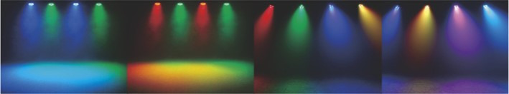

63 64